**(U) References:**

a. (U) Annex E: US Army Cadet Command JROTC AY 24-25 Annual Training Guidance

b. (U) FM 7-22, Army Physical Readiness Training, 8 October 2020.

**1. (U) Overview:** Every mission has some measure of danger and consequences; in view of this, we put safety and risk management at the front of our considerations. Safety and risk management are critical to mission success, therefore, we want to provide an overview of safety considerations while planning, developing, and participating in selected training events. Our primary focus in this appendix is on military obstacle and confidence courses. We will briefly outline the current tendencies to negotiate the Marine Corps style obstacle courses, and then reference other types of confidence courses that provide additional challenges. We will also outline some safety and risk management considerations regarding negotiating the obstacles and for participating in other training events.

a (U) Negotiating confidence course obstacles are excellent physical, mental, and psychological training events for youth development. They serve to highlight both individual and team fitness and enhance confidence building techniques for success.

b (U) As more and more programs are adding the standard Marine Corps style obstacle courses, this guide will help you to know how to properly execute each obstacle. The standard course is 300 meters long with 14 obstacles.

**2. (U) General:** The following descriptions are of all of the Military Obstacle Course events from #1 to #14 (refer to pictures).

**Military Obstacle Course Layout and Execution**

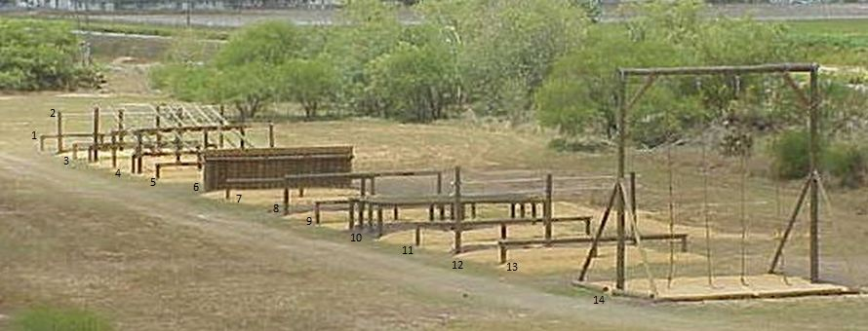

The course is 24 feet wide and has two lanes for participants to run. The descriptions below are of all of the obstacle course events from #1 on the south end to #14 (refer to photo).

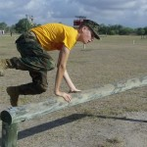**Events #1, 3, 5, 7, 9, 11 and 13: Low Jumps –** These events are low hurdles that are constructed from telephone poles. The top log of the hurdle is 2 1/2 feet high.  Participants may jump or vault over the hurdles. These events are spaced between the other events throughout the obstacle course.

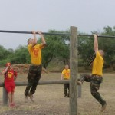**Event #2: Up and Over Bar –** This event is a high bar that is 8 feet off the ground.  Participants must go over the top of the bar either by executing a kip or by a technique referred to as a “college boy roll.” Executing this technique requires the participant to do a pull-up and then hook one armpit over the bar. They must then hook the opposite leg over the bar and in one motion kick down with the free leg while rolling over the bar.

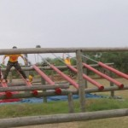**Event # 4: Combination –** This event is actually made up of 3 different obstacles to negotiate. The first one is Hand Over Pipes followed by the Log Walk and finishes up with the High Roll Over Log. Participants approach the obstacle and step up on the low balance log and jump up to the Hand Over Pipes. They then hook their feet on the pipes and slide down until they reach the Log Walk. They then stand up and walk down the logs and jump up onto the High Roll Over Log, hang from the log and drop to the ground.

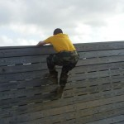**Event #6: Log Wall –** This event is a wall constructed from telephone poles and covered with 2 feet x 6 feet boards. Participants approach the wall and jump up grabbing the top. They then pull themselves up until they can get their elbows on top of the wall. Once they reach this point, they swing one leg up on top of the wall and roll off the back side.

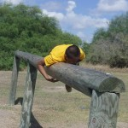**Event #8: Medium Roll Over Log –** This is a single log roll over that is 5 1/2 feet high. Participants must jump up to get their stomach on top of the log and then roll over the opposite side.

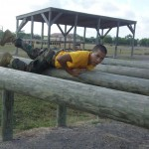**Event #10: Four Vault Logs –** This event is a series of four logs spaced 4 feet apart. Each of the logs is 4 1/2 feet high. Participants must vault or roll over all of the logs. Participants learn that getting a rhythm on this event is crucial to running a low time on the course.

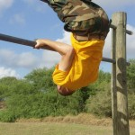**Event #12: Double Pull Over Bar –** This event is similar to the Up and Over Bar except that it has two bars. The first bar is located 8 feet above the ground and the second bar is 1 foot higher. Participants must pull up on the first bar until they can grab the second bar. They then pull themselves up until they can get both knees on the lower bar. They then reach over the top bar and grab the lower bar with palms outward, slowly lower themselves down over the bar, hang from the lower bar and drop to the ground.

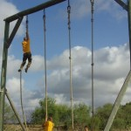**Event #14: Rope Climb –** This is a series of 20 feet high ropes that each participant must climb and touch the top of the rope before lowering themselves back to the ground. Participants must be careful when lowering to the ground and use hand over hand technique rather than simply slide down the rope which can cause rope burn.

**3. Confidence Course Obstacles:** Most confidence courses have some measure of danger and consequences for those who negotiate the obstacles. One of the most noted publications outlining confidence courses was the 26 October 2012 edition of FM 7-22. While this publication has recently been revised, the revised edition does not include the detailed overview of the confidence course obstacles still used by many of our units and other organizations. With that, we still want to highlight the obstacles that were included in that publication so as to ensure our units are aware of those approved for training, those not approved, and those that need conditions to be mitigated before use. The details, diagrams, execution techniques, safety considerations, and references concerning the following lists of obstacles are outlined specifically in Appendix E of FM 7-22, 26 October 2012 revised on 8 October 2020).

**a. (U) Confidence Course Obstacles approved for Training:**

• The “Belly Robber” (FM 7-22, dated 26 Oct 12, Item E-79 – Fig. E-12)

• The “Tough Nut” (FM 7-22, dated 26 Oct 12, Item E-69 – Fig. E-11)

• The “Inclining Wall” (FM 7-22, dated 26 Oct 12, Item E-76– Fig. E-12)

• The “High Step Over” (FM 7-22, dated 26 Oct 12, Item E-56 – Fig. E-9)

• The “Six Vaults” (FM 7-22, dated 26 Oct 12, Item E-59 – Fig. E-9)

• The “Easy Balancer” (FM 7-22, dated 26 Oct 12, Item E-60 – Fig. E-9)

• The “Hip-Hip” (FM 7-22, dated 26 Oct 12, Item E-65– Fig. E-10)

• The “Island Hoppers” (FM 7-22, dated 26 Oct 12, Item E-67– Fig. E-10)

• The “Swing, Stop, and Jump” (FM 7-22, dated 26 Oct 12, Item E-58– Fig. E-9)

• The “Belly Crawl” (FM 7-22, dated 26 Oct 12, Item E-72 – Fig. E- 11)

b. **(U) Confidence Course Obstacles NOT APPROVED for Training:**

• The “Tough One” (FM 7-22, dated 26 Oct 12, Item E-80– Fig. E-12)

• The “Slide for Life” (FM 7-22, dated 26 Oct 12, Item E-70 – Fig. E-11)

• The “Confidence Climb” (FM 7-22, dated 26 Oct 12, Item E-78 – Fig. E-12)

• The “Skyscraper” (FM 7-22, dated 26 Oct 12, Item E-77 – Fig. E-12)

• The “Tarzan” (FM 7-22, dated 26 Oct 12, Item E-74 – Fig. E-11)

• The “Low Belly Over” (FM 7-22, dated 26 Oct 12, Item E-71 – Fig. E-11)

• The “Dirty Name” (FM 7-22, dated 26 Oct 12, Item E-73 – Fig. E-11)

• The “Low Wire” (FM 7-22, dated 26 Oct 12, Item E-57 – Fig. E-9)

• The “Belly Buster” (FM 7-22, dated 26 Oct 12, ItemE-62– Fig. E-10)

c. **(U) Confidence Course Obstacles NOT APPROVED for Training unless additional safety measures are in place:**

• The “Reverse Climb” (FM 7-22, dated 26 Oct 12, Item E-63 – Fig. E-10)

Ground under near side of obstacle must be covered with sawdust, sand, shredded tire or similar material to lesson impact of fall. Wood must be free of nails and splinters. Support braces must be padded. Spotters must be used between the support posts.

• The “Weaver” (FM 7-22, dated 26 Oct 12, Item E-64 – Fig. E-10)

Ground under obstacle must be covered with sawdust, sand, shredded tire or similar material to lesson impact of fall. Wood must be free of nails and splinters. Spotters should be used in the center. Two safety pads 5X8X2 must be used under the apex. Unless the height of the apex is less then 7ft high.

• The “Balancing Logs” (FM 7-22, dated 26 Oct 12, Item E-66 – Fig. E-10) - Must not be more than two feet off the ground at any point

**4. (U) Safety considerations for Army JROTC co-curricular training events**

a (U). (U) All training must be conducted IAW TRADOC safety regulations. Whether Cadets are training on a major FORSCOM installation, a TRADOC installation, a small National Guard installation, on a high school campus, or at any other location. TRADOC safety regulations will be fully adhered to, or the training is NOT to be conducted.

b (U). USACC JROTC units do not participate in Extreme High-Risk events. Additionally, High Risk training events, i.e., Rappelling sites, must be inspected as often as necessary to ensure safety is maintained at all times. Of note, a change to the Cadet Command JROTC rappel policy calls for all JROTC Cadets to rappel using pre-fabricated nylon rappel seats. Self-tied Swiss Seats are no longer authorized for JROTC rappelling.

c. (U) Serious Incident Reports (SIRs): Serious incidents, accidents, and injuries will be reported through command channels within 24 hours (telephonic notification as a minimum) as outlined in Cadet Command memo, Serious Incident Reports (SIRs), dated February 2015.