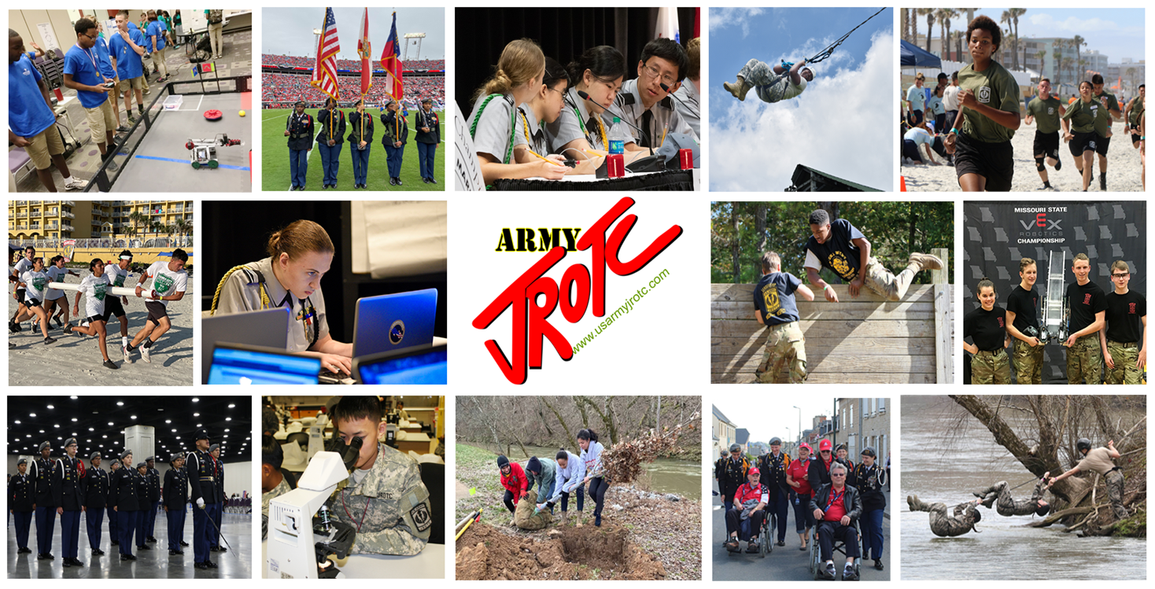

THE U.S. ARMY JUNIOR ROTC INSTRUCTOR HANDBOOK

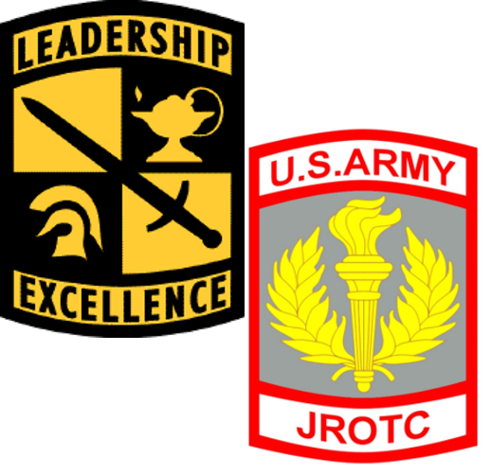

“To Motivate Young People to be Better Citizens”
THE U.S. ARMY JUNIOR ROTC INSTRUCTOR HANDBOOK
AUGUST 2024

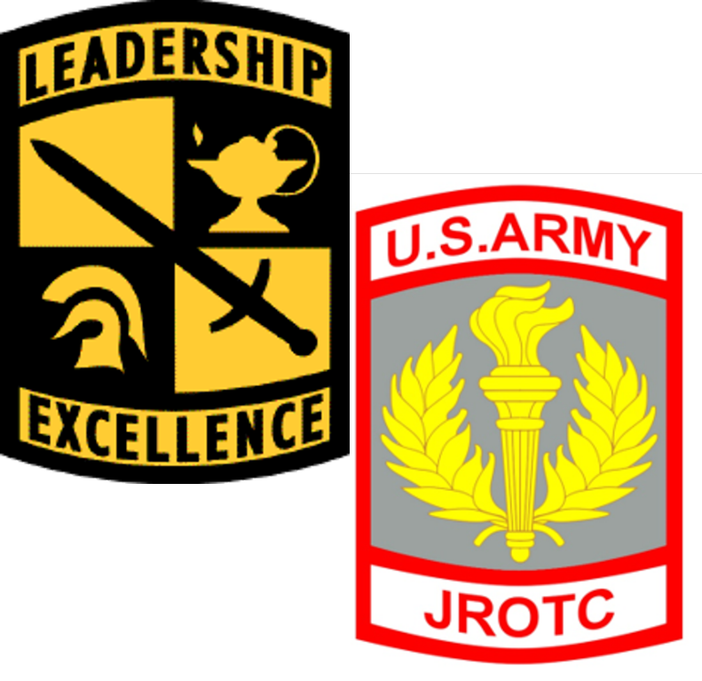
PREPARED BY:
U.S. Army JROTC
394 2nd Dragoons Road
Fort Knox, Kentucky 40121
Phone: 800-347-6641
Website: https://www.usarmyjrotc.com

TABLE OF CONTENTS

TABLE OF CONTENTS 3
GENERAL PROGRAM INFORMATION 6
1-1 MISSION 6
1-2 MISSION PHILOSOPHY 6
1-3 PROGRAM GOALS 6
1-4 CHARACTER OF PROGRAM 6
1-5 ENROLLMENT REQUIREMENTS 7
1-6 COMMAND AND CONTROL 7
1-7 ORGANIZATIONAL ROLES AND FUNCTIONS 7
1-8 LINES OF COMMUNICATION 10
1-9 POLICY OF NONDISCRIMINATION 10
1-10 BENEFITS TO THE SCHOOL 10
1-11 BENEFITS TO THE STUDENT 10
1-12 JROTC SUMMARY 11
1-13 REFERENCES 11
INSTRUCTOR MANAGEMENT 12
2-1 INSTRUCTOR MANAGEMENT (NEW) 12
2-2 INSTRUCTOR PAY (NEW) 12
2-3 INSTRUCTOR CONTRACTS 13
2-4 INSTRUCTOR ELIGIBILITY (NEW) 14
2-5 BACKGROUND CHECKS 14
2-6 JROTC INSTRUCTOR RESPONSIBILITIES 14
2-7 SERIOUS INCIDENT REPORTS (SIRs) 14
2-8 JROTC HEADQUARTERS AND BRIGADE POINTS OF CONTACT 15
2-9 ADDITIONAL DUTIES 15
2-10 PERFORMANCE COUNSELING/SCHOOL EVALUATIONS 15
2-11 INSTRUCTOR/CADET OR STUDENT FRATERNIZATION 16
2-12 INCIDENTS OF MISCONDUCT 16
2-13 TRAINING AND PROFESSIONAL DEVELOPMENT 17
2-14 INSTRUCTOR UNIFORMS 17
2-15 POINT OF CONTACT 19
2-16 REFERENCES 20
CADET MANAGEMENT (NEW) 21
3-1 JROTC CADETS 21
3-2 ADMISSION OF STUDENTS 21
3-3 EIGHTH GRADE PARTICIPATION 21
3-4 UNIFORM WEAR 22
3-5 CONDUCT WHILE IN UNIFORM 23
3-6 HAZING AND HARASSMENT 23
3-7 SAFETY 23
3-8 WEAPONS FIRING 24
3-9 POINT OF CONTACT 24
3-10 REFERENCES 24
UNIT MANAGEMENT 25
4-1 SCHOOL SUPPORT 25
4-2 APPLICATION PROCESS (NEW) 25
4-3 UNIT RETENTION 25
4-4 RECURRING REPORTS AND REQUIREMENTS 26
4-5 AMENDMENT OF DA FORMS 3126 AND 3126-1 28
4-6 ADVERSE ACTIONS 28
4-7 ADMINISTRATION 28
4-8 POINT OF CONTACT 28
4-9 REFERENCES 28
LOGISTICS 30
5-1 BOND/INSURANCE CERTIFICATE 30
5-2 SUPPLIES AND EQUIPMENT 30
5-3 HERALDRY ITEMS 30
5-4 POINT OF CONTACT 32
5-5 REFERENCES 32
CURRICULUM 33
6-1 THREE COMPONENTS OF THE JROTC CURRICULUM 34
6-2 CURRICULUM 35
6-3 CURRICULUM FRAMEWORK 36
6-4 ELECTIVE LESSONS 36
6-5 LEARNING STRATEGY 36
6-6 JROTC CO-CURRICULAR EVENTS 37
6-7 OTHER AREAS OF SPECIAL EMPHASIS 37
6-8 MARCH2SUCCESS 37
6-9 GETTING STARTED WITH THE CURRICULUM -- NEW-HIRE CURRICULUM READINESS CHECKLIST 37
6-10 POINT OF CONTACT 39
6-11 REFERENCE 39
JROTC PUBLIC WEBSITE 40
7-1 AUDIENCE 40
7-2 CADET NEWS AND RECOGNITION 40
7-3 NATIONAL EVENTS 40
7-4 EMPLOYMENT 41
7-5 INSTRUCTOR RESOURCES 41
7-6 CADET RESOURCES 41
7-7 POINT OF CONTACT 42
7-8 REFERENCES 42
INSTRUCTOR REFERENCES 43
STEM AND CYBER Resources and Opportunities 47
LAWS, REGULATIONS AND DIRECTIVES 51
ACRONYMS AND ABBREVIATIONS 52
JROTC NEW Instructor Priorities of Work (Example) 55
Army JROTC Co-Curriculars 57
FORMS 61
DD Form 3200 JROTC Instructor Prohibited Activities Acknowledgement (NEW) 61
DD FORM 3202 Memorandum of Agreement Between Military Service and School District to Establish and Operate a JROTC Unit (NEW) 64
DD Form 3203 JROTC Student Code of Conduct and Parent/Guardian Consent Form (NEW) 69
DA Form 3126 Application and Contract for Establishment of a JROTC Unit 73
DA Form 3126-1 Application and Contract for Establishment of a National Defense Cadet Corps Unit 77
DA Form 7410 Evaluation Worksheet Potential Army JROTC Program 81
ARMY JROTC INSTRUCTOR CREED (Draft) 85
CADET CREED 86

GENERAL PROGRAM INFORMATION

1-1 MISSION
It is a purpose of the Junior Reserve Officers' Training Corps to instill in students in United States secondary educational institutions the values of citizenship, service to the United States (including an introduction to service opportunities in military, national, and public service), personal responsibility and a sense of accomplishment.

1-2 MISSION PHILOSOPHY
The Army Junior Reserve Officers’ Training Corps (JROTC) is the Department of Defense’s (DoD) largest youth program globally. The JROTC Program’s mission philosophy is “To Motivate Young People to be Better Citizens” and it is a service to our nation that provides Cadets the motivation and skills to graduate from high school and become successful citizens. The program instills in students from secondary educational institutions the values of citizenship, service to the community and the United States, personal responsibility, and a sense of accomplishment. While participation in JROTC does not require a military service commitment, Junior ROTC Cadets may qualify for advanced placement in the Senior ROTC Program or the Active or Reserve Components of the Armed Forces. Cadets may be authorized the enlistment grade of Private First Class (PFC/E-3) if they have completed three or more years of JROTC with a recommendation from the Senior Army Instructor (SAI).

1-3 PROGRAM GOALS
JROTC provides Cadets the motivation and skills to become successful citizens by:

- Improving physical fitness
- Remaining drug-free
- Thinking critically and creatively
- Communicating effectively
- Working as a team member
- Graduating from high school
- Pursuing meaningful careers, especially in the areas of science, technology, engineering, and mathematics (STEM)

1-4 CHARACTER OF PROGRAM
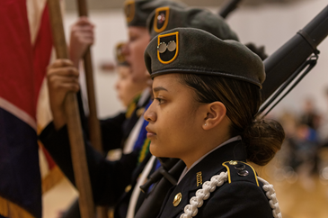
Participants in the program are provided an opportunity to acquire relevant general knowledge and to develop personally. Schools providing a JROTC program will offer their students the challenge of intellectual inquiry facilitated by military instructors who are experienced leaders. The program provides an atmosphere designed to develop, enhance, and sustain leadership qualities. Through student-centered classroom activities and outside-related experiences, the participants acquire the knowledge, skills, self-discipline, patriotism, sense of responsibility, and respect for authority that will better prepare them for the future. The program enables Cadets to better serve their country as leaders and citizens, whether they join the workforce, the military, or pursue higher education.
SGM Paul C. Grey Memorial Drill Championships Color Guard

1-5 ENROLLMENT REQUIREMENTS
JROTC is open to all students enrolled in and attending a full-time regular course at an institution offering JROTC instruction or at a full-time accredited educational activity that has an agreement with the host institution (to include home school students) to allow the student to participate in JROTC. Students must be above the seventh grade during the school year of enrollment and maintain an acceptable standard of academic achievement and standing as required by the JROTC Program and the host institution. Cadet enrollment must be 10 percent of the number of students enrolled in the institution who are in a grade above the 7th grade, or 100 students, whichever is less.

1-6 COMMAND AND CONTROL
Army Junior Reserve Officer’s Training Corps (JROTC) is a worldwide program with over 1,700 units, approximately 4,000 instructors, and more than 275,000 Cadets. Such a wide distribution of units requires centralized decision-making to ensure consistency in goals and policies across a large and diverse population. The United States Army Cadet Command (USACC) Commander relies heavily on the Senior Reserve Officer’s Training Corps (SROTC) leadership to maintain standards across the Command.
The Brigade Commanders’ involvement is crucial to overseeing and supervising both SROTC and JROTC programs within their Brigade. The Brigade Commander, the JROTC Brigade Chief, and their staff observe and verify that the USACC Commander’s guidance, policies, and decisions are being executed and followed.
The JROTC Directorate assists the command by developing and monitoring JROTC Policies, Plans, Operations, Curriculum, and Budget. The JROTC Directorate communicates guidance from Cadet Command Headquarters to the instructors through the governing document for JROTC, Cadet Command Regulation (CCR) 145-2. Any recommendations for changes to JROTC policies or programs will be staffed through the JROTC Director and approved by the USACC Commander.
This Instructor Handbook defines the duties and responsibilities of the USACC Brigade staff and instructors. It focuses on the organizational structure of the Brigade SROTC and JROTC staff and includes command and control, responsibilities, and functions at all levels of the Command.

1-7 ORGANIZATIONAL ROLES AND FUNCTIONS
The successful command and control of the Brigade is predicated on the roles assigned to members of the command. The missions and functions to be carried out or executed by USACC organizations are vital. Personnel are assigned to Brigade JROTC staff to meet the desired ratio of 1:30 (1 DA civilian for 30 programs) to ensure proper program oversight and that processes are streamlined to facilitate day-to-day operations.
a. Brigade Commanders. Brigade Commanders have operational control of the JROTC units within their area of operations.

(1) Exercise command control of JROTC programs by enforcing USACC policies and directives at high schools within their Brigade.
(2) Direct, supervise, and coordinate matters about the organization, training, and administration of JROTC programs by AR 145-2, CCR 145-2, and other command guidance as directed by the Commander, USACC.
(3) Provide guidance and assistance to Directors of Army Instruction (DAI)/Senior Army Instructors (SAI) and Army Instructors (AI) concerning retention, curriculum, instructor training, administration, property accountability, and logistics. Provide staff assistance and support for JROTC instructor requirements in these areas.
(4) Evaluate the performance of the Brigade JROTC Chief and their staff.
(5) Inform the Director, JROTC when problems arise because of contractual support agreements between support installations and JROTC programs.
(6) Monitor the visitation/inspection policy to ensure JROTC units (schools) and DAI offices are visited by members of the Brigade staff following CCR 145-2. Conduct at least one assistance or Accreditation visit annually to all JROTC programs.
(7) Maintain liaison with school officials, USAR, ARNG, U.S. Army Recruiting Command (USAREC), and other local officials or supporting organizations.
(8) Exercise command responsibility in managing the brigade’s JROTC operational budget. The brigade staff will plan and execute separate budgets for JROTC and SROTC. JROTC funds cannot be used to support SROTC activities.
(9) Assign a member of an affiliated SROTC battalion to serve as the JROTC Liaison Officer (LNO), who acts as the point of contact for JROTC instructors seeking assistance or support from a SROTC Program.
(10) The Brigade JROTC staff will function under the guidance of the Brigade Commander and have direct communications with the JROTC Director. To facilitate information flow and streamline communications, Brigade Commanders have direct access to all levels of the USACC staff for support. The JROTC Brigade Chief is responsible for managing the JROTC personnel and the JROTC units within the Brigade.
(11) Consolidate Brigade adverse action recommendations, research allegations, receive legal reviews, and provide the evidence to the USACC DCG/DCO for a decision.
(12) Report all Serious Incident Reports (SIRs) involving any JROTC personnel to USACC per USACC SIR policy and copy the JROTC Director.
b. JROTC Director. The JROTC Director develops operational policies/plans, and curriculum and formulates the operational budget for JROTC. The JROTC Director is the functional proponent for the JROTC Program by supporting the Brigade Commanders. The JROTC Director has an open line of communication with the Brigade Commander and the JROTC staff concerning the daily operations of the JROTC Program. The JROTC Director:
(1) Communicates USACC guidance to the instructors through AR 145-2, CCR 145-2, and other regulatory guidance.
(2) Develops policies, plans, operations, budget, and curriculum for JROTC. Any recommendation for changes to JROTC policies or programs will be staffed through the JROTC Directorate for approval by the USACC Commander. The JROTC organizational structure is shown below.

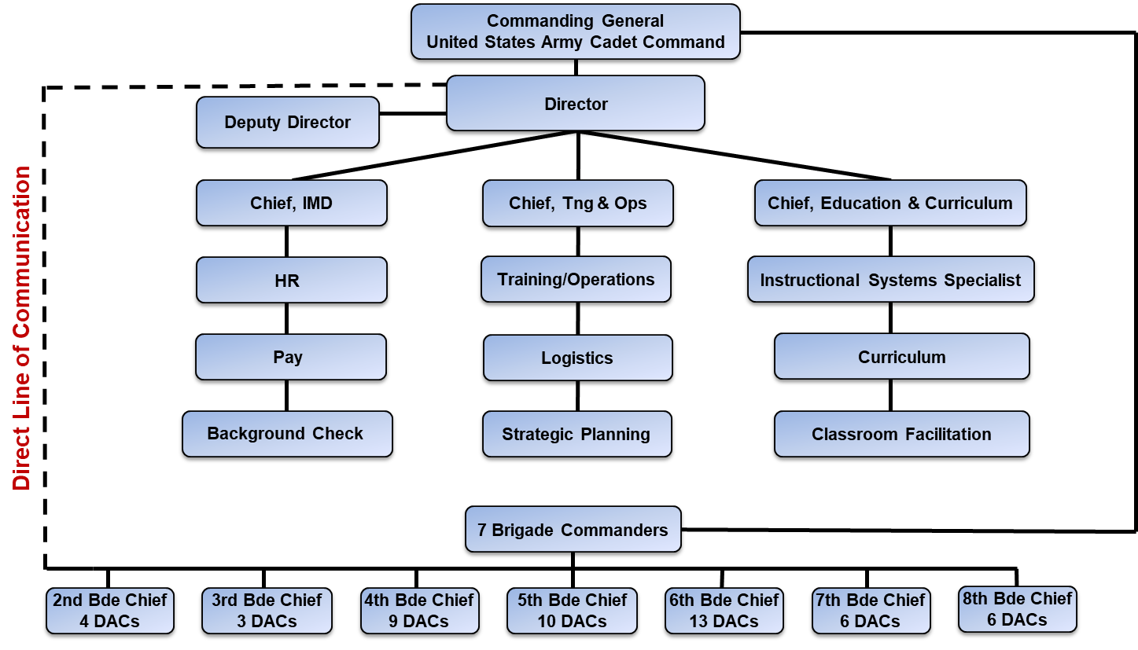

c. Professor of Military Science (PMS) and Senior Military Instructor (SMI). The PMS and SMI can be a vital source of support for the JROTC program. All SROTC universities must be affiliated with JROTC programs within their area (as determined by the Brigade Commander). Below are some recommendations for how the PMS and SMI can assist the JROTC program.
(1) Establish a routine and supportive relationship with JROTC units.
(2) Serve as the Guest Speaker at JROTC events.
(3) Attend or host local competitions at the university.
(4) Visit JROTC units or designate someone to visit at least once each year.
(5) Sponsor a university/college campus visit for JROTC Cadets (LET 3 & 4).
(6) Provide SROTC Cadets to support summer training, judge/score events, and conduct physical training.
(7) Serve as the inspector for the in-rank inspections and other activities.
(8) Aid or training to stand-alone units for supply procedures.
(9) Develop a formalized affiliation with JROTC units.
(10) Provide the Brigade Commander with feedback on instructor adherence to policies.
(11) Serve as the liaison to high school administration.

1-8 LINES OF COMMUNICATION
The lines of communication facilitate an instantaneous exchange of information between Cadet Command Headquarters, Brigades, and instructors. The JROTC Directorate communicates daily with the Brigade JROTC staff; however, any major taskings will come from a Cadet Command G-3, Tasking to the Brigade. Any request for action from the Unit must be communicated to the Brigade JROTC Chief.
The JROTC website http://www.usarmyjrotc.com/ is also an excellent source of information for instructors. The JROTC directorate publishes all major changes and announcements on the JROTC website. Instructors will be given a username and password to access the internal JROTC web portal. It is recommended that instructors check the JROTC web portal as often as possible to get current information.

1-9 POLICY OF NONDISCRIMINATION
School authorities must agree, as a condition for participation in the program, to adhere to a policy of nondiscrimination based on race, religion, color, gender, sex, marital status, political affiliation, physical disability, national origin, sexual orientation, gender identity, or status as a parent concerning admission or subsequent treatment of Cadets/students and instructors. They also agree to abide by Headquarters, Department of the Army (HQDA), and U.S. Army Cadet Command (USACC) contractual and regulatory guidance. JROTC units will adhere to USACC contracts, regulations, and policy guidance that schools and districts implement. All violations of this policy are generally within the purview of school authorities. Any substantiated breaches of this policy must be promptly reported to USACC. School authorities have a reasonable period to resolve violations. It is the responsibility of the school official, Director of Army Instruction (DAI), SAI, or any unit member knowing these charges, but who is not a party to the violation, to make this report.

1-10 BENEFITS TO THE SCHOOL
The benefits of having a JROTC program in the school are a new nationally accredited curriculum with flexibility to support your institutional needs, student leadership development, character education, and life skills. Other benefits include increased parental and student involvement, higher student attendance, higher graduation rates, and decreased discipline problems. JROTC provides access to a nationwide support network.

1-11 BENEFITS TO THE STUDENT
The JROTC program has many benefits to the students including earning credits for graduation. Cadets participate in a nationally accredited classroom curriculum and co-curricular activities where they can demonstrate the leadership, teamwork, and decision-making skills they developed in the classroom. Some of the co-curricular events include Color Guard, Drill Competitions, Archery, Raider Challenge, Robotics, CyberPatriot, CyberStart, JROTC Cadet Leadership Camps (JCLCs) and STEM camps, the National Flight Academy and the JROTC Leadership and Academic Bowl (JLAB) among others.

1-12 JROTC SUMMARY
JROTC is an innovative leadership and citizenship program that consistently moves forward to improve a Cadet’s leadership, social, emotional, and academic skills. The program includes classroom academic studies, character education, team building, leadership opportunities, intramural competitions, field trips, and unique training opportunities. JROTC does NOT recruit for the Armed Forces nor do the Cadets have a service obligation. JROTC also does NOT conduct combat skills training. JROTC is a highly visible program with many benefits and advantages for the student, the school, the parents, and the community. All instructors are positive role models selected based on their honorable military service, experience, training proficiency and expertise, people skills, and professionalism. Any JROTC Instructor who fails to uphold these traditions is subject to discipline by school/school district policies and potential decertification as a JROTC Instructor.

1-13 REFERENCES
Title 10, United States Code, Section 2031, Department of Defense Instruction (DODI) 1205.13, Army Regulation (AR) 145-2, and U.S. Army Cadet Command Regulation (CCR) 145-2.
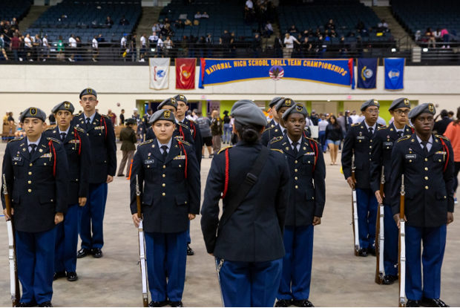
The National High School Drill Team Championships at the Ocean Center in Daytona Beach, Florida

INSTRUCTOR MANAGEMENT
Army JROTC was implemented with the passage of the National Defense Act of 1916. Under the provisions of the 1916 Act, high schools were authorized the loan of federal military equipment and the assignment of active or retired military personnel as instructors. The 1964 Revitalization Act opened JROTC up to the other services and replaced most active-duty instructors with retired Armed Forces members who work for and are cost-shared by the school districts.
The success of the JROTC program depends upon qualified instructors. To support the Junior ROTC program, the Army authorizes schools to employ commissioned and noncommissioned officers certified by the USACC Commanding General to lead JROTC units as administrators and instructors.
Schools must employ an adequate number of officers and noncommissioned officers to host a JROTC program. Unit staffing authorization levels will be based on the annual Opening Enrollment Report figures. Instructor staff increases will be based on the enrollment figures for two consecutive years to avoid instability in the instructor force. All schools hosting a JROTC program must employ two JROTC Instructors; one officer or warrant officer (with a baccalaureate degree) to serve as the SAI and one noncommissioned officer or warrant officer to function as the Army Instructor (AI). JROTC Instructors are host school employees, subject to the same policies, procedures, and terms of employment as any other teacher. School authorities shall apply their hiring procedures to employ certified instructors.

2-1 INSTRUCTOR MANAGEMENT (NEW)
To ensure the best-qualified instructors are referred to schools, USACC JROTC will certify and assist schools in hiring qualified retired officers and noncommissioned officers. USACC will advertise vacancies, provide an eligibility list of instructors to school officials, conduct security background checks, and manage instructor personnel records. A new requirement is all Instructors will complete and sign the new DD Form 3200, JROTC Instructor Prohibited Activities Acknowledgement form. This form supplements DoDI 1205.13 and will be read and signed before performing JROTC Instructor duties. The purpose of this form is to establish expected behavior for JROTC Instructors and to confirm each Instructor understands and agrees to the statements included in this form. New Instructors shall complete this form prior to the first day of employment, and this form will be certified annually within 30 days of the first day of school each subsequent year. As a minimum, the signed original will be retained in the instructor’s training/performance record while assigned to JROTC duty. This form will be validated concurrently with the Annual In-person inspection of the program.

2-2 INSTRUCTOR PAY (NEW)
Army Junior ROTC is authorized to provide cost-share reimbursement for Army Retired, Reservist, and Veteran Soldiers employed by the school whose qualifications are approved by the Commanding General, USACC. The enacted FY2024 NDAA requires a new “JROTC Standardized Instructor Pay Scale” (JSIPS) system. USACC uses the employing school's physical address to determine locality pay. The following tables determine an instructor's minimum wage for equivalency purposes only. The tables reflect minimum annual salaries; most instructors are on a 10- or 11-month contract. The annual salary amounts will be divided by 12 to get a monthly amount. Pay increases, if any, will be effective at the beginning of the next academic school year. The final bill also included an amendment that prohibits DOD from reducing the total compensation of any JROTC instructors or administrators employed as of the date of enactment.
The school must submit a request for hire letter and Department of Defense (DD) Form 2767 (Annual Certification of Pay and Data) within 30 days from the effective hire date to obtain monetary allowances from the Army for payment of authorized instructors. The appropriate school finance or personnel representative and the instructor shall sign the forms. Failing to submit this form will delay reimbursement to the school district for instructors’ pay.
- Enlisted Instructors

JS-1 | Less than an Associate degree | Equivalency GS 10, Step 2
JS-2 | Associate degree | Equivalency GS 10, Step 3
JS-3 | Bachelor’s degree | Equivalency GS 10, Step 4
JS-4 | Master’s degree | Equivalency GS 10, Step 5
JS-5 | Juris Doctor or Doctorate degree | Equivalency GS 10, Step 6

- Officer Instructors

JS-6 | Bachelor’s degree | Equivalency GS 11, Step 6
JS-7 | Master’s degree | Equivalency GS 11, Step 7
JS-8 | Juris Doctor or Doctorate degree | Equivalency GS 11, Step 8

Instructors relocating to a different school district with a JROTC unit will fall under the JSIPS locality table for the new school. The pay scale for relocations will be based solely on grade and the highest academic degree held.

2-3 INSTRUCTOR CONTRACTS
The school or school district is the employing agency of all JROTC personnel. The length of the employment contract as negotiated by the JROTC Instructor and school officials should be up to 11 months but for no less than 10 months per year. It is recommended that employing agencies negotiate 12-month contracts with instructors to continue year-round program management. However, reimbursement will only be for up to 11 months. Schools are expected to treat instructors as other Department Heads and teachers in the school (e.g., ensure they are involved in budget and other school decisions, including in professional/staff development, offer the same opportunities for teacher of the year, receive equitable supplemental pay/stipends for co-curricular activities, etc.).

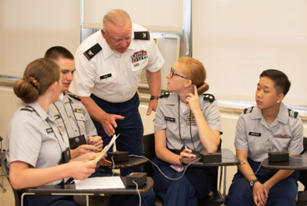
2-4 INSTRUCTOR ELIGIBILITY (NEW)
Army officers and noncommissioned officers who are retired or separated with an honorable discharge within the past 5 years with at least 10 years of service may serve as instructors in Army JROTC units. Additionally, officers and noncommissioned officers who are active participating members of the selected reserve at the time of application and have not yet reached retirement eligibility may serve as instructors. USACC will determine the applicant’s eligibility, suitability, and qualifications through a satisfactory interview, physical examination, service record, review of the application packet, and other materials to serve as Army JROTC Instructors.
A JROTC instructor teaches Cadets the JROTC curriculum

2-5 BACKGROUND CHECKS
All applicants are required to have a background check upon initial hire. USACC vets all instructors per DoDI 1402.05 (Background Checks on Individuals in DoD Childcare Services Programs) and Army Directive 2014-23 (Conduct of Screening and Background Checks for Individuals Who Have Regular Contact with Children in Army Programs) with a Childcare National Agency Check and Inquiries (CNACI) background investigation and periodic re-verification every 5 years. All JROTC Instructors must have a complete comprehensive CNACI investigation and be found suitable to remain a JROTC Instructor. Instructors who are found unsuitable are removed from the JROTC classroom.

2-6 JROTC INSTRUCTOR RESPONSIBILITIES
Army JROTC Instructors manage the unit’s educational, administrative, and operational aspects and implement policies and procedures administered by the school and the U.S. Army. The SAI is the department head and chief instructor of the JROTC unit. The senior instructor will coordinate with school officials to establish procedures relating to the administration, control, and training of JROTC Cadets.

2-7 SERIOUS INCIDENT REPORTS (SIRs)
District Administrators, Principals, or Assistant Principals will notify the Brigade Headquarters directly or via the DAI/SAI upon discovering any misconduct or adverse action involving any JROTC personnel. The DAI/SAI and Brigade Headquarters will proactively gather information to promptly submit Serious Incident Reports (SIRs) to USACC. Brigades will report all serious incidents required by the USACC SIR Policy. The names of Cadets will not be listed in SIRs. Cadets will be referred to as Cadet [Redacted].

2-8 JROTC HEADQUARTERS AND BRIGADE POINTS OF CONTACT
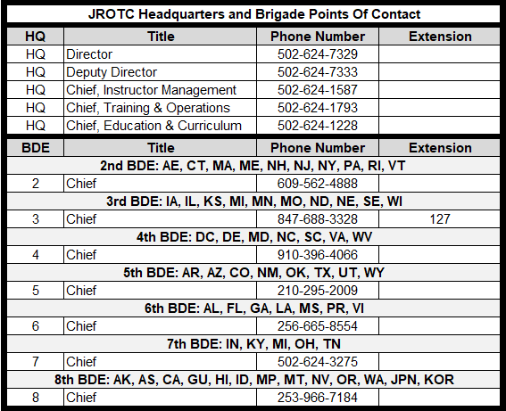

2-9 ADDITIONAL DUTIES
JROTC Instructors are to perform only those duties connected with the instruction, operation, and administration of the JROTC program. During the normal academic day, individuals employed as JROTC Instructors will not perform duties or teach classes in any discipline other than stated in the program of instruction. JROTC Instructors should not be used as substitute teachers for other classroom instruction. This provision is not intended to preclude JROTC Instructors from serving on committees or performing other routine duties regularly rotated among other teachers in the school. The SAI and AI are faculty members and teach an integral part of the school’s curriculum. They are subject to the same co-curricular assignments and duties as other teachers, such as homeroom and study hall monitors. They usually receive the same benefits of sick leave, holidays, and vacations.
The school may contract with the instructor for additional services, outside of the normal academic day. Still, such services may not conflict with, or be substituted for teaching the JROTC curriculum. Instructors are employees of the host institution and are not required to travel to other locations to provide instructions at a non-host institution.

2-10 PERFORMANCE COUNSELING/SCHOOL EVALUATIONS
The Army considers the performance review, appeal process, and complaint system available in a school district adequate protection for instructors from unfair evaluations. Mandatory performance counseling will be documented on a school-approved document or in a memorandum during the initial counseling and subsequent counseling conducted semi-annually. SAIs will conduct initial performance counseling for AIs within the first 30 days of employment and semi-annually. DAIs will conduct initial counseling for SAIs within their district within the first 30 days and then on a semi-annual basis. For schools under a Brigade Headquarters control (no DAI), the Brigade JROTC Chief, or designated staff member, will counsel SAIs. Brigade JROTC Chiefs will conduct performance counseling for programs with DAIs. Instructor’s performance will be reviewed using performance counseling forms, unit visits, classroom evaluations, and inspections. Reviews will determine whether the instructors, individually and collectively, are effective and efficient in conducting instruction, unit operations, and JROTC activities per regulations and other directives. Performance counseling should address satisfactory or unsatisfactory performance. Forms may be downloaded from https://www.usarmyjrotc.com.

2-11 INSTRUCTOR/CADET OR STUDENT FRATERNIZATION
In addition to your existing school policies, Instructors are prohibited from engaging in and tolerating fraternization or unprofessional relationships with Cadets. JROTC Cadets and Instructors are required by Title 10, U.S.C. 102 to sign an acknowledgment of these prohibited activities (See Appendix A). Examples include, but are not limited to physical contact with a student, socializing in an overly familiar manner such as texting, social networking, tweeting, blogging, etc. Instructors will not allow Cadets to perform personal services (e.g., babysitting, house sitting, pet sitting, yard work, etc.). Counseling or talking to Cadets alone behind closed doors is prohibited. Violations of these policies may result in probation/decertification for JROTC personnel. Cadets who violate this policy may be disenrolled from the program.

2-12 INCIDENTS OF MISCONDUCT
The U.S. Army supports the Department of Education’s (ED) Title IX Regulations and your institution’s Title IX Policy. While instructors attend their JROTC Instructor Certification, USACC informs all instructors that they are mandatory reporters of Title IX violations and to report any violations (or suspicions of violations) to their Title IX Coordinator. They are also informed to report all violations or suspicions of abuse or domestic violence involving a minor to local authorities. Lastly, they are told to communicate with their institution’s leadership and Title IX Coordinator to ensure that they understand their institution’s policies as well as their state and local laws regarding reporting sexual harassment, assault, dating violence, domestic violence, and stalking.
When any incident occurs, host educational institutions must notify the USACC Brigade Commander of any misconduct allegations by their school employee hired as a JROTC Instructor. When the host schools investigate their JROTC Instructors for misconduct or remove those instructors from their roles, USACC will immediately suspend instructor qualifications and may decertify instructors based on the outcome of the school or local law enforcement agency investigation.
USACC has policies, procedures, and training designed to prevent JROTC Instructor misconduct and rigorously screen applicants to recommend the best-qualified applicant to a host educational institution for employment consideration. The vetting process includes Federal background checks, New Instructor Orientation Training, and the hiring school districts’ subsequent local and state employment requirements. Additionally, there are annual training requirements for current instructors including presentations by external groups and a requirement to complete “The Good Teacher” online training annually.

TRAINING AND PROFESSIONAL DEVELOPMENT
JROTC Instructors must participate in and complete the instructor training plan and professional development at the JROTC School of Cadet Command (JSOCC). Completing the instructor training plan is a requirement for initial certification and continued certification for JROTC Instructors. See the instructor training plan below.
- JROTC Basic Certification:
  - Phase 1 - Distance Learning Course (Completion within 6 months of hire)
  - Phase 2 - Resident Course (Completion within 12 months of hire)
- Continual Learning Education Course (Completion within 2 years of hire)
- Brigade Training Workshop (Completion once every 3 years)
- Resident Advanced Recertification Course (Completion every 5 years of hire)

New instructors must complete the JROTC School of Cadet Command (JSOCC) basic certification where they receive interactive training on sexual harassment and Instructor/Student boundaries. The basic certification training includes two phases – a distance learning phase completed within six months and a resident phase completed within 12 months of hire. The distance learning course orients new instructors to the JROTC program and the roles and responsibilities of working within a secondary learning institution. The goal is to develop foundational skills for computer literacy and a working knowledge of secondary education concepts, trends, and issues. The resident phase provides the new instructors with a simulated classroom environment to develop the classroom management skills and techniques required to execute the JROTC program to support both JROTC and school goals. The resident phase includes an Ethics block of instruction where Instructors receive sexual harassment and boundaries training.

All instructors must attend a Brigade Training Workshop at least once every three years to maintain certification and proficiency. These workshops include a review of the Army Sexual Harassment/Assault Response and Prevention Program (SHARP). Instructors also must complete “The Good Teacher” training annually presented through Will Interactive. “The Good Teacher” is a unique interactive tool to help educators learn how to foster proper teacher-student relationships and make appropriate interventions when witnessing sexual misconduct by colleagues. Instructors must review the guidance for Instructor/Cadet/Student boundaries, which must be annotated in the instructor’s records.

Additionally, as employees of the schools, Instructors must also complete all sexual harassment, student interaction, and other training required by their respective school districts and state Boards of Education.

INSTRUCTOR UNIFORMS
Army JROTC instructors will wear Army uniforms IAW AR 670-1, DA Pam 670-1,
and AR 145-2.

Army JROTC instructors (including DAIs and their staffs, SAIs, AIs, and cost-shared MPSs) will wear the currently approved Army uniform with authorized insignia and rank while performing JROTC duties, training and other appropriate times as directed by CG, USACC. Instructors will not wear the Cadet black jacket with a JROTC patch sewn on it or make any modifications not authorized by regulatory guidance. The current Army Service Uniform (ASU) or current Army-approved uniform is the standard for the classroom and campus, and regardless of approved occasional deviations, it will be the uniform worn most of the school year. During all instruction and training, the authorized rank will be the retired rank or the pay grade for which instructors are reimbursed. The key document used to determine the retired rank or pay grade is DD Form 214.

(1) Instructors are authorized to wear the Army PT uniform on days when Cadet Challenge or other physical activities take place (this uniform was purchased at no
expense to the government).

(2) Instructors may wear an appropriate collared shirt (e.g., with the JROTC or school emblem) on designated (by the principal) school spirit days (no more than one time per week).

(3) Under no circumstances will jeans or similar clothes be worn during the school day unless specifically authorized by school authorities for a special event.

(4) Instructors may wear the currently authorized Operational Camouflage Pattern (OCP) for adventure training, Raider Challenge, Air Rifle training and competitions, scheduled work in the unit supply room, and JCLCs. The OCP will not be worn on campus during the normal school day. Exceptions must be submitted in writing to the Brigade commander and endorsed by the principal or superintendent.

(5) All JROTC instructors (including DAIs and their staffs, SAIs, AIs, and cost-shared MPSs) authorized to wear the Army uniform will wear the Class “A” or “B” uniform when accompanying Cadets to events where Cadets are required to wear the Cadet/Army Service Uniform (C/ASU). Likewise, instructors will wear OCPs when accompanying Cadets to events where Cadets are required to wear the OCP uniform.

(6) The hosting organization establishes the uniform for competitions IAW this regulation. The OCP uniform will be worn during national marksmanship safety training including competitive events.

(7) JROTC instructors are required to wear the black Army beret. JROTC instructors are not authorized to wear maroon, brown, or tan berets or similar items as part of their uniforms while conducting JROTC duties. However, instructors branched as Special Forces (18 series MOS) are authorized to wear the Green Beret at retirement. Wear of the Service Cap with the ASU is optional.

(8) JROTC instructors are authorized to wear the full-color US flag insignia on the right sleeve of the OCP uniform. Instructors are not authorized to wear the subdued flag insignia on the OCP uniform.

(9) Instructors who violate the uniform policy may be placed on probation.

Wearing Army uniforms is prohibited in the following situations:

(1) In connection with furthering any political or commercial interests.

(2) When engaged in off-duty civilian employment.

(3) When participating in public speeches, interviews, picket lines, marches, rallies, or public demonstrations, except as authorized by the CG, USACC.

(4) When attending any meeting or event that is a function of or is sponsored by an extremist organization.

(5) When wearing the uniform would discredit the U.S. or the Army.

(6) When specifically prohibited by Army regulations.

(7) During services not a part of JROTC duties for which payments or benefits are received that would tend to demean the uniform, the wearer, or JROTC.

(8) When selling tickets at events in violation of this regulation.

Distinctive Unit Insignia (DUI):

(1) JROTC instructors will wear the Cadet Command shoulder sleeve insignia on the left sleeve of the OCP uniform. Insignia of former wartime units may be worn on the right sleeve, all other awards and decorations to include regimental affiliation will be worn IAW AR 670-1.

(2) JROTC instructors may wear the school DUI insignia on the flash of the beret and the shoulder loop on the ASU for enlisted instructors if TIOH has approved the design. When worn, it will be as prescribed in DA Pam 670-1. JROTC instructors will wear the USACC insignia if the school-approved insignia is not worn.

2-15 POINT OF CONTACT
Chief, Instructor Management Division at 1-800-347-6641 or e-mail: usarmy.knox.usacc.mbx.hq-jrotc-im@army.mil.

2-16 REFERENCES
Army Regulation 145-2 and Cadet Command Regulation 145-2

CADET MANAGEMENT (NEW)
Army JROTC Cadets are students currently enrolled at the host school or are transported from another school within the same district to participate in JROTC. Students must have completed the 7th grade. For JROTC to have its greatest impact on students, participants must adhere to a prescribed set of standards that might be more stringent than those of other students or the larger community.
Participation in Army JROTC is voluntary, and parents must agree to their students’ participation. A new requirement is all Cadets, and their parent/guardian must complete and sign the DD Form 3203, JROTC Student Code of Conduct, and Parent/Guardian Consent Form attached for your reference. The purpose of this form is to share the expectations of the program, the expected behavior, and the unacceptable behavior of all students and instructors taking part in the JROTC program. By initialing next to each statement, Cadets acknowledge and agree to the expected/prohibited behavior explained in each section.

3-1 JROTC CADETS
Students who meet eligibility requirements for membership, are enrolled in the program, and participate in the curricular and co-curricular activities of the unit are considered JROTC Cadets. A student ineligible for enrollment as a Cadet may be authorized to attend JROTC instruction as a Participating Student if the SAI and principal determine the student does not adequately meet the standards to qualify as a Cadet. The number of Participating Students will not exceed 2% of the program without a waiver from the Brigade Commander. Students enrolled in an adaptive physical education program may participate. However, the school will provide any special equipment or additional instructors needed to instruct these students at no cost to the government. The school must also coordinate with the instructor to ensure these students do not disrupt the presentation of the JROTC curriculum.

3-2 ADMISSION OF STUDENTS
JROTC units will reflect a cross-section (within 10%) of the school’s population. Administrators and counselors must work closely with JROTC Instructors to ensure the students enrolled represent the diversity of the school enrollment to maintain the balance required for an effective program (e.g., under normal circumstances there should not be more special needs students or students with disciplinary problems in JROTC than exist in the overall school population). College-bound students should also have many opportunities to participate in JROTC. Ideally, the program will have a balance of ethnicity, gender, and race, though programs need not stay within 10% of the school’s population in each area. However, if the unit has an obvious imbalance in any area, administrators, counselors, and JROTC Instructors must make a conscious effort to determine the reason and address it.
Note: Students with disabilities, with the concurrence of the principal, may participate. Participation from the entire student body should be the goal of every unit.

3-3 EIGHTH GRADE PARTICIPATION
Students above the seventh grade and physically co-located with a participating JROTC unit of the ninth grade or above may participate in JROTC. With regards to curriculum management, a potential recommendation for programs with 8th graders includes beginning with Leadership, Education, and Training (LET) 1, followed by LET 2 for 9th graders, LET 3 for 10th graders, LET 4 for 11th graders, and LET 4L for 12th graders, with heavy electives and greater involvement with the underclass teaching for those 12th graders. Another suggestion includes implementing LET 1 Core and available electives between 8th and 9th grade, with the remaining years proceeding as normal: LET 2/10th grade, LET 3/11th, and LET 4/12th. Again, these are suggestions, and the JROTC program recommends the instructors work with their school and district administration to identify what best fits their school and Cadets.

3-4 UNIFORM WEAR
Cadet Command Regulation 145-2 prescribes the uniform, uniform devices, and the manner of wear for JROTC Cadets. The Army ensures Cadets have the proper number and type of issue-in-kind uniforms.

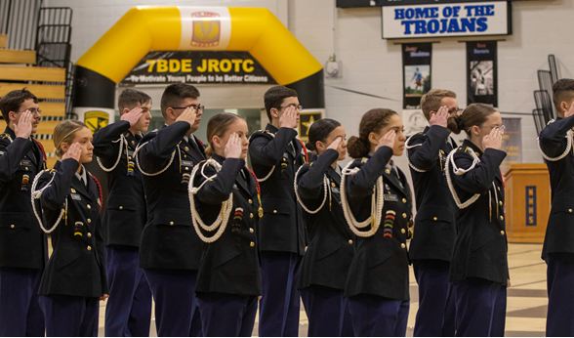
SGM Paul C. Grey Memorial Drill Championships in Hardin County, Kentucky

The JROTC Cadet Army Service Uniform (C/ASU) and the Operational Camouflage Pattern (OCP) are authorized for wear by JROTC Cadets. The C/ASU uniform is the standard for the classroom and campus. Cadets will only wear the OCP for adventure training, JCLC, or special team activities. Cadets will not wear the OCP on campus during the normal school day. JROTC Cadets will wear the Class “A” or “B” uniforms as explained in CCR 145-2 one day per week, except in Military Schools that have requested and received permission to wear a distinctive uniform. CCR 145-2 describes the fitting standards and wearing instructions for the JROTC uniforms. The cadets are responsible for maintaining all uniform items in a clean and orderly condition during the school year and before turn-in. It is the instructor’s responsibility to ensure the Cadets adhere to standards.
While this guide prescribes policies, assigns responsibilities, and provides guidance for the Army JROTC/National Defense Cadet Corps (NDCC) programs, its primary focus is assisting our nation's students to become better citizens. This mission is a shared responsibility between the U.S. Army and our nation's school systems and provides a baseline of values for our students, instructors, and programs. Personal appearance standards while wearing JROTC uniforms will align with all school standards and promote inclusion. Although Cadets are encouraged to maintain personal appearance standards, no Cadet will be penalized, graded for their appearance outside of the proper wear of their uniform, or excluded from wearing the JROTC uniform. We encourage all schools to avoid implementing standards that would discourage students from participating in your JROTC program or wearing the uniform.

3-5 CONDUCT WHILE IN UNIFORM
While Cadets wear their JROTC uniforms, they are representing the Army and its values. Uniforms should only be worn while traveling to or from, or while participating in official JROTC activities. JROTC Cadets should avoid wearing the uniform when:
- In connection with any political or commercial interests
- Engaged in off-duty civilian employment
- Participating in public speeches, interviews, picket lines, marches, rallies, or public demonstrations, except as authorized by the Commanding General, USACC
- Attending any meeting or event that is a function of, or is sponsored by an extremist organization
- Wearing the uniform would bring discredit upon the Army
- Specifically prohibited by Army regulations

Inappropriate behavior while in uniform is prohibited. This behavior includes, but is not limited to horseplay, fighting, verbal threats, and physical attacks. JROTC Cadets will not engage in public displays of affection (PDA) while in uniform.

3-6 HAZING AND HARASSMENT
Hazing is defined as directing someone of lesser rank to perform a humiliating act that entails the surrender of dignity and self-respect, or a hazardous action that exposes one to physical danger or bodily harm. Hazing is strictly forbidden. Harassment of any Cadet, by anyone, of any rank, is strictly prohibited. Misuse of any authority will not be condoned or tolerated. Actions of this nature include using improper or abusive language. There will be no coercing of lower-class JROTC members into activities they would not otherwise participate in.
Any hazing, harassment, or bullying by JROTC Instructors and Cadets is strictly prohibited. This could result in probation/decertification for JROTC personnel. Instructors will disenroll Cadets violating this policy from the program. Instructors and Cadets are not authorized to require Cadets to execute any form of physical punishment or discipline. No unit or school sponsoring a JROTC unit may encourage, facilitate or otherwise condone secret societies, private clubs, or military tactical training as part of the JROTC program. Cadets may not continue in JROTC if such activity is student-led. Instructors engaged in such activity will be de-certified from teaching JROTC if involved. The JROTC unit will be closed where such activity is determined to be school-sponsored.

3-7 SAFETY
Cadet physical safety is always given first consideration. Strict adherence to school and command safety policies is mandatory.

3-8 WEAPONS FIRING
Air Rifle firing is permitted only during marksmanship training and competitions sanctioned by USACC. All participating Cadets must have written permission from the current principal and the Cadet’s parents to participate.

3-9 POINT OF CONTACT
Chief of Training and Operations at 1-800-347-6641 or e-mail:
usarmy.knox.usacc.list.hq-jrotc-training-and-ops@army.mil.

3-10 REFERENCES
Army Regulation 145-2 and Cadet Command Regulation 145-2
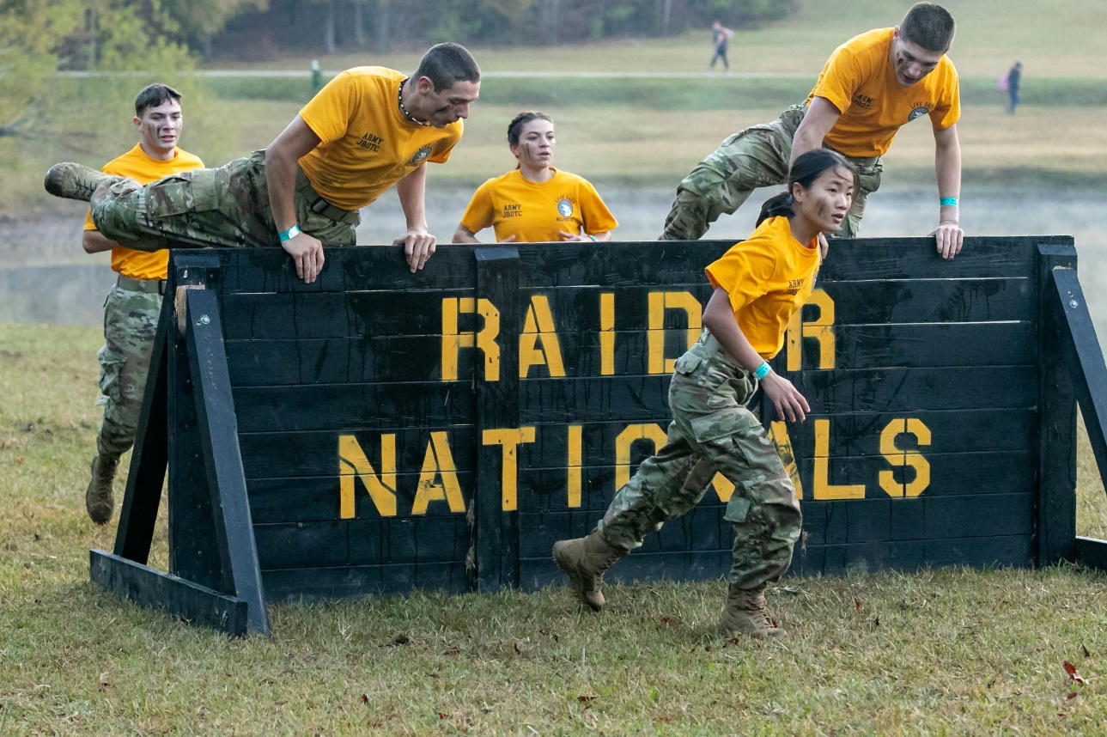
The U.S. Army National Raider Championships in Molina, Georgia

UNIT MANAGEMENT
The school Principal is ultimately responsible for the operation and management of the Army Junior ROTC unit at the school. His/her participation in the program is critical to the unit’s success.

4-1 SCHOOL SUPPORT
The school should promote the success of JROTC and support JROTC community activities. Examples of this include, but are not restricted to, fostering partnerships with support organizations (e.g., the Veterans of Foreign Wars, American Legion, Military Order of World Wars, etc.), scholarship and grant requests for JROTC, co-curricular activities, advocating for credit other than elective (e.g., Civics credit, Health credit, History credit, PE credit, etc.) and supporting Junior Achievement partnerships and supporting college credit for JROTC instruction. Additionally, the school must provide transportation to JROTC activities equitably with other academic and co-curricular activities.

4-2 APPLICATION PROCESS (NEW)
Schools desiring to establish a JROTC unit must complete a DD Form 3202 (Memorandum of Agreement Between Military Service and School District to Establish and Operate a JROTC Unit) and a DA Form 3126 (Application and Contract for Establishment of a Junior Reserve Officers’ Training Corps Unit), (https://armypubs.army.mil/ProductMaps/PubForm/DAForm.aspx) or DA Form 3126-1 (Application and Agreement for Establishment of a National Defense Cadet Corps Unit), (https://armypubs.army.mil/ProductMaps/PubForm/DAForm.aspx) and apply to the respective Brigade to the JROTC Directorate. The forms are attached for reference. Applications will contain the date the school desires to begin course instruction, any former participation in JROTC, and a statement if there is an application for JROTC with another service. The JROTC Directorate will evaluate the application and place the school on the Order of Merit list (OML). As new program authorizations become available, The JROC Director will send the next school on the OML an offer letter through the Brigade. The applicable Brigade HQ will validate the DA Form 3126 and conduct a site survey using DA Form 7410, Evaluation Worksheet, Potential Army JROTC Unit, (https://armypubs.army.mil/ProductMaps/PubForm/DAForm.aspx) when the school is approved for a JROTC unit. USACC Regulation 145-2, Chapter 3 contains additional information on the application process and establishment of new JROTC units.

4-3 UNIT RETENTION
Requirements of the DoD and DA Form 3126 contractual agreement (forms are attached for reference) between the Army and the school district must be adhered to. Compliance is checked annually. School officials are notified in writing, by the Director of Army JROTC, of the specific nature of deficiencies, when a visit or review indicates the school is not meeting required standards. Schools must maintain a Cadet population of 100 students or 10% of the school population.
Cross-enrollment is the population of Cadets who are enrolled in a school other than a feeder school and do not have a host JROTC program. Instructors will not instruct at a facility other than the host school. The Army has an inspection program for JROTC, which annually rates the School Program, the DAI offices, and the Corps of Cadets. If the administration, instructors, or DAI are deficient in any area, they will be placed on probation. These probations will not affect the results of the Cadet inspections and reports. The inspections and reports for the Cadets will determine the unit’s rating. However, if the Cadets fail to meet the minimum standards, the unit will be placed on probation.

4-4 RECURRING REPORTS AND REQUIREMENTS
Below is a listing of the most common recurring reports and requirements due to the JROTC Directorate.

Recurring Reports and Requirements
Report Type | Date due to USACC | Reference | Additional Information
Annual Recurring Suspense
Degree Completion Transcript (Required by USC 10) | Within 5 Years of Initial Hire for AIs | CCR 145-2 | SAI (Bachelor's Degree), AI (Associate Degree)
JLAB- Level I Registration | Annual | CCR 145-2 | Mandatory online-either Academic or Leadership
Marksmanship Safety Training (Enrollment/Recertification) | Annual | CCR 145-2 | https://thecmp.org/training-tech/jmic-jrotc-marksmanship- instructor-course/
Ethics Training (Enrollment/ Recertification) | Annual | CCR 145-2 | https://access.willinteractive.com/the-good-teacher-legacy-access/the-good-teacher
Coaching Rubric or School Evaluation | Annual during AV / JPA | CCR 145-2 | https://www.usarmyjrotc.com/library
Acceptable Use Policy (AUP): | Annual | G6 | https://cs.signal.army.mil/default.asp
Primary Hand Receipt | Annual | AR 735-5 | Primary Hand Receipt Holder sends to G4/PBO
Primary Hand Receipt | Annual | CCR 145-2 | Primary Hand Receipt Holder sends to G4/PBO
Insurance Certificates (Bonds and COIs) | Annual | CCR 145-2 | Primary Hand Receipt Holder sends to G4/PBO with Hand Receipt
Pay Forms - DD 2767 | Annual | CCR 145-2 | Upload into JCIMS Only
Pay Forms – DD 2754 | Annual | CCR 145-2 | Upload into JCIMS Only
Every 5 Years or Event Driven
Serious Incident Report | As Required | USACC Policy
GPC Training - New Cardholders and Billing Officials | As Required | GPC SOP
JSOCC (Enrollment/ Recertification) | Basic Course within 24 months of hire date | CCR 145-2
 | Advanced Course every 5 years | CCR 145-2
Photos (Digital 4x6 inch Only) | Every 5 years | CCR 145-2 | Check JCIMS Acct - 3/4 Length on White Background. Instructor's name, date, and school name must be on photo or in e-mail message
Primary Hand Receipt | As Required | CCR 145-2 | Must be completed within 30 days of a Primary Hand Receipt Holder transition
AUGUST
New School Year Set up | 15-Aug | CCR 145-2 | Submit in JUMS (update unit/school info)
SEPTEMBER
Curriculum Plan | 15-Sep | CCR 145-2 | From Curriculum Manager and PDF only-annually per LET Level to BDE
OCTOBER
Opening Enrollment Report (JUMS) | 15-Oct | CCR 145-2 | Submit in JUMS
Intention of Graduates Report (JUMS) | 15-Oct | CCR 145-2 | Submit in JUMS
JCLC (AAR) | 31-Oct | CCR 145-2
NOVEMBER
DECEMBER
JANUARY
FEBRUARY
JCLC Locations and Dates | 15-Feb | CCR 145-2
JCLC Residual Risk HIGH | 15-Feb | CCR 145-2 | Any Deliberate Risk Assessment Worksheet (DRAW) with a residual risk level of HIGH must be approved by the CG, USACC
Mid-Year Enrollment | 15-Feb | CCR 145-2 | This is for accelerated block/flex schools-submit in JUMS
JROTC Essay Contest Submittals | Feb | USACC OPORD | Suspense date will be IAW USACC OPORD
MARCH
APRIL
Instructor of the Year Nomination (DAI/SAI/AI) | Apr | USACC OPORD | Suspense date will be IAW USACC OPORD
Unfunded Requests (UFR) | Apr | USACC Annual Budget Plan and USACC OPORD | Suspense date will be IAW USACC OPORD
MAY
JUNE
Unit Report (JUMS) | 30-Jun | CCR 145-8-3 | Submit in JUMS
Program Assessment Rating Tool (PART) (JUMS) | 15-Jun | CCR 145-2 | Submit in JUMS
School Input for Annual Assistance Visits & JPA schedule | 1-Jun | CCR 145-8-3 | After suspense date, Brigade will schedule without school input
JULY

4-5 AMENDMENT OF DA FORMS 3126 AND 3126-1
If any changes are necessary to DA Form 3126 or DA Form 3126-1, submit them via DA Form 918B (Amendment to Application for Establishment of Army Reserve Officers’ Training Corps Unit) through the Brigade to HQ, USACC, ATTN: ATCC–JR (JROTC Directorate). HQ, USACC will forward major changes to HQDA (DAPE–MPO).

4-6 ADVERSE ACTIONS
Schools with JROTC units are bound by a mutually executed contract to comply with all agreement provisions. If a school fails to fulfill its obligations enumerated in the contract, Brigade Commanders will act following the CCR 145-2. Brigade Commanders may recommend probation for schools not in compliance (e.g., insufficient enrollment, not having 2 instructors, etc.) or recommend disestablishment if the school is unable or unwilling to fulfill its responsibilities as outlined in the contract.

4-7 ADMINISTRATION
Units will organize, maintain, and dispose of files following Army guidance. Unit files normally consist of administrative records, supply and equipment records, and Cadet academic or personnel records. The accountability of equipment, curriculum, and curriculum-related items, uniforms, and supplies funded by the Army must satisfy current JROTC guidance and be properly documented.

4-8 POINT OF CONTACT
Chief, Training and Operations at 1-800-347-6641 or e-mail:
usarmy.knox.usacc.list.hq-jrotc-training-and-ops@army.mil.

4-9 REFERENCES
Army Regulation 145-2 and Cadet Command Regulation 145-2

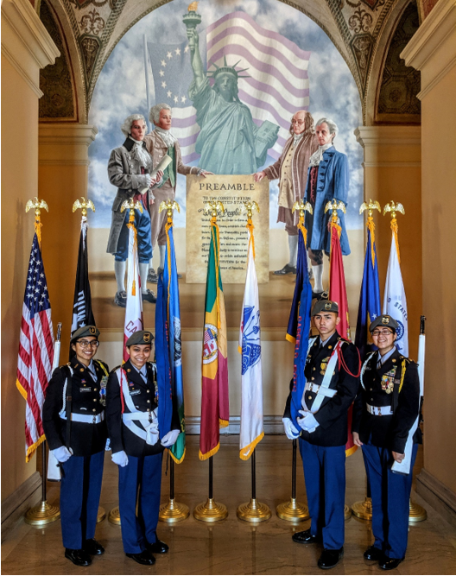
Garfield High School JROTC Color Guard – Los Angeles, California

LOGISTICS
The USACC JROTC Training and Operations Division provides guidance and procedures for bond/insurance certificates, supply management, uniforms, equipment, archery equipment, robotics, Raider Challenge equipment, drill rifles, and air rifles for units that have a Color Guard, a Drill Team or a Marksmanship Team.

5-1 BOND/INSURANCE CERTIFICATE
Bonds or insurance exist to safeguard government property and must always be maintained by the institutions in a current “premium paid” status and designate the “U.S. Army” as the payee. Host institutions will forward a current copy of a bond or insurance certificate to U.S. Army Cadet Command, ATTN: Army JROTC Directorate, Fort Knox, KY 40121. Oversight to ensure that all bonds and insurance are current and comply with AR 735-5 will be accomplished through scheduled inspection visits. Appointment of an Army instructor to serve as a Military Property Custodian (MPC) and oversee logistical issues will be submitted to the appropriate command headquarters within 30 days of establishing a unit or designating the instructor. The Army instructor designated as the MPC will be given one class period daily to accomplish these duties.

5-2 SUPPLIES AND EQUIPMENT
The Army shall provide the school with instructor manuals, student materials, multimedia software, learning support supplies, IT/automation equipment, and operations equipment at no cost. The designated MPC will requisition, store, issue, and account for all government property furnished to the institution for JROTC activities, including demilitarized weapons, air rifles, uniforms, and automation equipment. The MPC will follow procedures in DA Pamphlet 710-2-1, AR 710-2, and AR 735-5 for proper usage and storage of Army property.

5-3 HERALDRY ITEMS
Schools request the organizational flag, shoulder sleeve insignia (SSI), and shoulder loop insignia (SLI) designs by submitting a memorandum and an ROTC Request for Insignia form (available on the Institute of Heraldry (TIOH) website) through the Brigade to the JROTC Directorate Point of Contact (POC) for review and approval. The JROTC Directorate will submit the request for the design to TIOH. The Institute of Heraldry will contact the school program POC on the request form to confirm your information. Additional information is available on the JROTC website at https://www.usarmyjrotc.com/institute-of-heraldry/.
Once the design is completed, TIOH will electronically transmit the authorized heraldic item designs and procedures on obtaining flags, guidons, and streamers along with a certified manufacturer list. The school submits the request (DD Form 1348-6) online at www.heraldry.army.mil. Further steps are listed on the requisition document. Guidons are a standard design; schools submit a DD Form 1348-6 requisition online at www.heraldry.army.mil.
There is no charge for the design of an SSI or SLI. However, each school pays to manufacture its SSI and SLI through its JROTC budget. Units can use Military Personnel Army (MPA) and donated funds but cannot use Operations and Maintenance Army (OMA) funds. Schools are responsible for SSI and SLI procurement using a TIOH Certified Manufacturer list at https://tioh.army.mil/Catalog/VendorList.aspx. Additionally, there is no charge to replace guidons and an organizational flag with wear and tear every 5 years.
The following excerpts from AR 840-10, Flags, Guidons, Streamers, Tabards, and Automobile and Aircraft Plates, 17 July 2020 are provided for your reference:
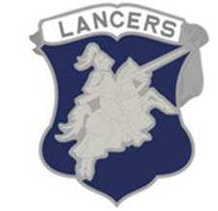
Shoulder Loop Insignia (SLI)
Size: Not larger than 1 1/4 inches (3.18 cm).
Purpose: Promotes esprit de corps.
Acceptable design elements: Military/educational items showing the nature of the organization; historical items; special achievement; mission of the school, unit, or area; elements of school seal. The school motto may appear on a scroll attached to the SLI.
Unacceptable design elements: Cartoon characters, logos, dates, cities, states, and letters "ROTC" or other letters as part of the design.

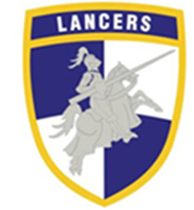
Shoulder Sleeve Insignia (SSI)
Size: Not larger than 3 1/2 inches (8.89 cm).
Purpose: Worn on the right shoulder sleeve; identifies ROTC unit.
Acceptable design elements: Mascot, distinctive buildings, landmarks, geographical or regional features (but not actual county or state outlines). The school's name or nickname may appear on a designation band or may be attached above/below the design.
Unacceptable design elements: Cartoon characters, logos, dates, cities, states, and letters.

Organizational Flag and Guidons
Each school is entitled to an organization flag and guidon(s). TACOM maintains standard base drawings from which organizational flags and guidons are produced. There is no charge to replace guidons and an organizational flag with wear and tear every 5 years.
Junior Reserve Officers Training Corps (JROTC) Flag
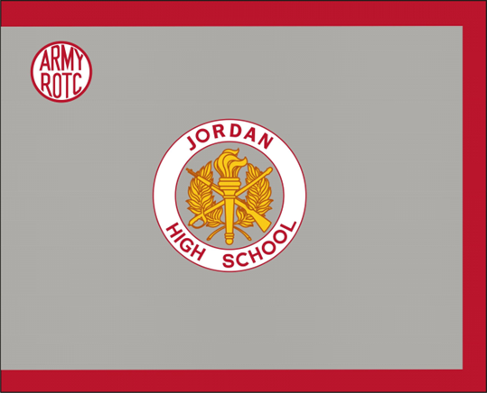
The flag is silver-gray fringed in scarlet. In the center is the JROTC device consisting of two arched olive branches with stems conjoined in base, forming a wreath, surmounted by a sheathed saber and rifle in saltire. Overall, in the vertical center is the ROTC torch enflamed, all in yellow. Around the center device is a white band edged in scarlet and inscribed with the school name in scarlet letters. The device with the designation scroll is 16 inches in diameter. In the upper hoist is the monogram “ARMY ROTC” in scarlet on a white disc edged in scarlet, 6 1/2 inches in diameter.

Junior Reserve Officers' Training Corps Companies or Batteries Guidon
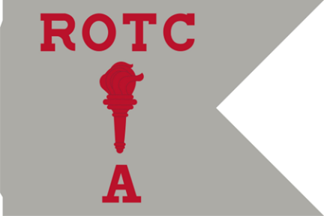
Guidons are silver gray with the ROTC torch enflamed between “ROTC” above and the company designation below. All letters are in scarlet.

National Defense Cadet Corps (NDCC) Flag
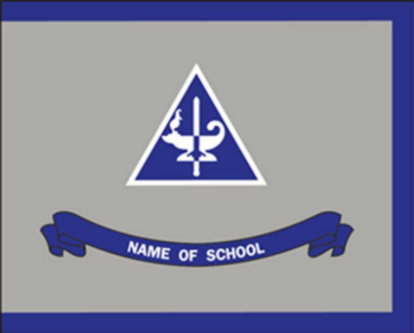
The flag is silver gray with ultramarine blue fringe. Centered on the flag is the National Defense Cadet Corps (NDCC) SSI in proper colors, 15 inches high. Below is an ultramarine blue scroll with the school's name in white letters.

National Defense Cadet Corps Company Guidons
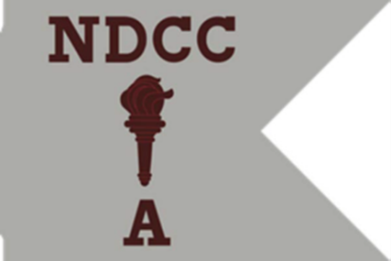
Guidons are silver gray with the ROTC torch enflamed, centered between “NDCC” above and the company designation below all in maroon.

5-4 POINT OF CONTACT
Chief, Training and Operations Division at 1-800-347-6641 or e-mail:
usarmy.knox.usacc.list.hq-jrotc-training-and-ops@army.mil.

5-5 REFERENCES
Army Regulation 145-2, Army Regulation 710-2, Army Regulation 735-5, DA Pamphlet 710-2-1, and Cadet Command Regulation 145-2

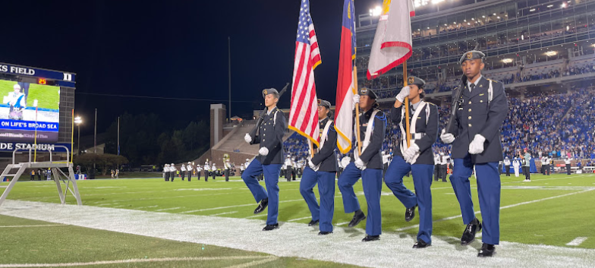

CURRICULUM
Lexington Senior High School JROTC Color Guard – Lexington, North Carolina
The Curriculum Guide provides the minimum requirements for successfully implementing the JROTC program. It contains the “Desired Learning Outcomes” of the JROTC program that support the mission, “To Motivate Young People to be Better Citizens.” JROTC Cadet training must be challenging, dynamic, interesting, and inherently educational.

Instructors and Cadets are encouraged to enrich and expand learning by seeking additional learning materials aligned with the JROTC program outcomes, core abilities, and competencies. Education and training must be properly sequenced and progressive throughout the Cadet’s career.

6-1 THREE COMPONENTS OF THE JROTC CURRICULUM
- Lesson Competencies. Each Lesson Plan includes targeted competencies for each lesson of the curriculum. They describe discipline-specific measurable and observable skills, knowledge, and attitudes. They also provide the specifications for assessing competency mastery (criteria and conditions).

Cadets demonstrate they have learned competencies by applying them. They are required to complete one or more of the following in each lesson:​
- Make a decision
- Perform a skill
- Perform a service
- Solve a problem
- Create a product

- Core Abilities. The core abilities all Cadets need for success result from the goals and values that drive the JROTC program. These abilities are cultivated through the JROTC curriculum. JROTC Core Abilities are:
- Apply critical thinking techniques
- Build your capacity for life-long learning
- Communicate using verbal, non-verbal, visual, and written techniques
- Do your share as a good citizen in your school, community, country, and the world
- Take responsibility for your actions and choices
- Treat yourself and others with respect

- Program Outcomes. Program Outcomes describe what learners will know and be able to do upon successfully completing the program. They provide documentation of the student’s and program’s growth and development for re-accreditation purposes. Army JROTC Program Outcomes include:
- Act with integrity and personal accountability as you lead others to succeed in a diverse and global workforce ​
- Engage in civic and social concerns in the community, government, and society ​
- Graduate prepared to succeed in post-secondary options and career pathways ​
- Make decisions that promote positive social, emotional, and physical health ​
- Value the role of the military and other service organizations

6-2 CURRICULUM
The JROTC program is a cooperative effort by the Army and the host institution to provide secondary school students with opportunities for total development. The Army JROTC curriculum is sequenced and consists of 4 Unit/LET levels that build upon each other. The advancement from the Unit/LET level must be completed in sequence. The sequencing within a Unit/LET level can be rearranged to meet the Instructor or situational needs of the classroom. A Unit/LET level should not be completed in one semester. There are enough approved electives for Instructors to use in addition to core required hours to teach in a school year.
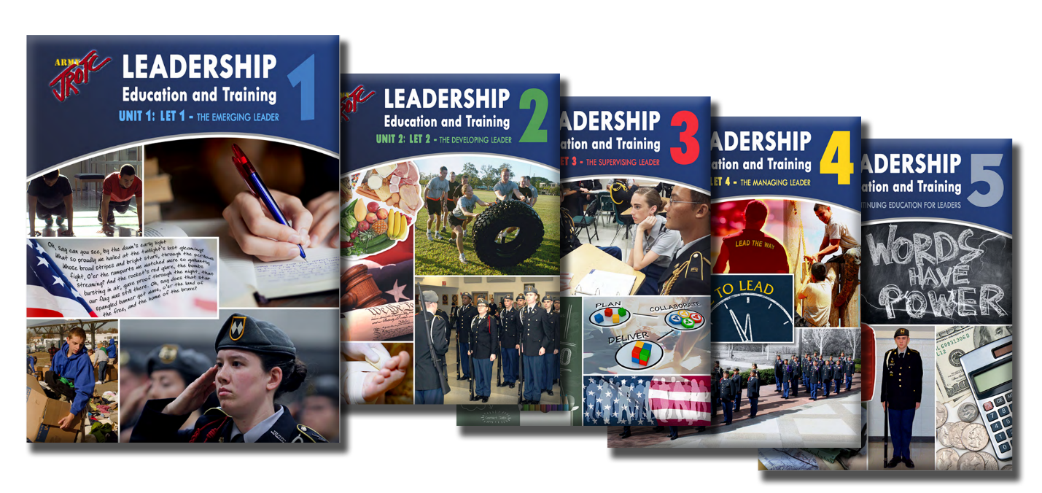

“The Emerging Leader” (Unit 1/LET 1): 68 Contact Core Hours. 51 Recommended Lab Hours.
This course is the first of the four core courses in the Army JROTC program. This course supports 22 lessons designed for first-year Cadets. Because the central focus of the JROTC program is to help develop strong leaders and model citizens, the first-year Cadets are introduced to content that will help their inner leaders to emerge. The knowledge, skills, and abilities acquired in this unit are covered in six chapters.

“The Developing Leader” (Unit 2/LET 2): 73 Contact Core Hours. 42 Recommended Lab Hours.
This course builds upon the mastery of LET 1 skills and abilities, providing Cadets with new and more challenging opportunities in leadership development. There are 24 active learning lessons within eight chapters.

"The Supervising Leader” (Unit 3/LET 3): 59 Contact Core Hours. 54 Recommended Lab Hours.
This course builds upon the mastery of LET 1 and 2 skills and abilities, providing Cadets with new and more challenging opportunities as a leader by overseeing planning, project implementation, and team personnel. Cadets at this level can acquire battalion staff positions and responsibilities and help integrate improvements in the local JROTC program and community. There are 20 active-learning lessons within seven chapters.
"The Managing Leader” (Unit 4/LET 4): 30 Contact Core Hours. 38 Recommended Lab Hours.
This course provides Cadets multiple opportunities to manage and lead in the battalion, school, and their respective communities. The LET 4 Cadet is ready to assume responsibilities and manage others. There are 12 active-learning lessons within six chapters.

6-3 CURRICULUM FRAMEWORK
The National JROTC Fitness Challenge Championships in Daytona Beach, Florida

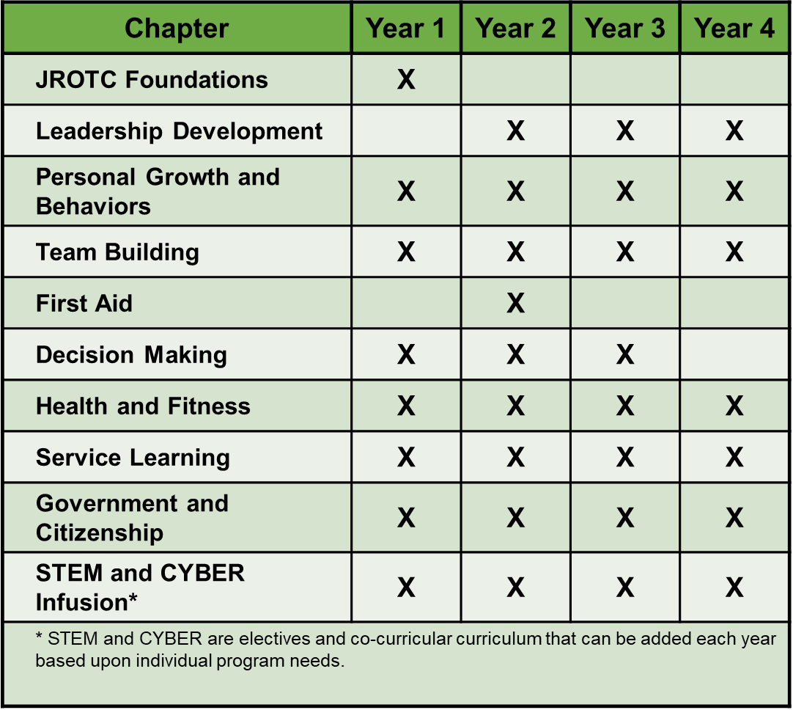

6-4 ELECTIVE LESSONS
The JROTC curriculum contains elective lesson resources to enhance the core curriculum content. These can be used to address new areas of content as required by the schools or districts and to increase the contact hours necessary for a one-credit high school course. These additional elective lesson resources enhance the Army JROTC program and are not meant for general school usage.

6-5 LEARNING STRATEGY
The core curriculum is taught using the 4-phase lesson plan which requires the Cadet to inquire, gather, process, and apply known and learned information. The JROTC curriculum provides assessment tasks to serve as tools for verifying and documenting Cadet competencies. These assessment tasks will provide feedback to instructors and give Cadets the tools necessary to develop learning strategies.

6-6 JROTC CO-CURRICULAR EVENTS
In addition to focusing on citizenship and academic achievement, the Army JROTC program provides a team-based environment that promotes self-awareness and a sense of accomplishment. Each JROTC unit provides mentally and physically challenging co-curricular activities that include some or all the following: service learning/community service, continuous improvement projects, JROTC Cadet Leadership Challenge, Raider Challenge Team activities, JROTC Leadership and Academic Bowl (JLAB), drill ceremonies and competitions, archery, civilian marksmanship competitions, drone and VEX robotics competitions. All schools will be allowed to compete in these various competitions. Many of these events involve STEM and schools are encouraged to promote cross-department participation. The objectives of these activities are to:
- Provide Cadets with the opportunity to practice leadership skills.
- Allow Cadets a chance to participate in citizenship-building exercises.
- Help Cadets develop team spirit and unit spirit.
- Develop in Cadets the skills to demonstrate individual mental and physical fitness.

Additional information on JROTC co-curriculars are contained in the attachments.

6-7 OTHER AREAS OF SPECIAL EMPHASIS
Army JROTC has made strides and continues to expand in the Cyber-Science arena, specifically, in the CyberPatriot program and the CyberStart project. The JROTC strategic plan includes increasing the number of teams participating in the CyberPatriot program, increasing the number of Cadets who participate in the CyberStart game, and researching additional Cyber-Science opportunities for JROTC Cadets through partnerships with universities, industry, scientific foundations, and other governmental organizations.

6-8 MARCH2SUCCESS
This free web-based platform offers online study materials to assist students in improving their scores on standardized tests including state exit exams, college entrance exams, and the Armed Services Vocational Aptitude Battery (ASVAB). March2Success includes self-paced study programs in math, English, and science, focusing on materials for grades 8-12. USACC promotes March2Success in the JROTC curriculum. Instructors should recommend March2Success to Cadets and other students who plan to apply for an ROTC Scholarship or an appointment to the U.S. Military Academy (USMA) at West Point. Students can use the program’s resources to improve their SAT/ACT scores and be more competitive for ROTC scholarship boards and USMA. It also includes information on college admissions, financial aid, and how to navigate the entire college application and acceptance process.
6-9 GETTING STARTED WITH THE CURRICULUM -- NEW-HIRE CURRICULUM READINESS CHECKLIST

- Upon being hired by a school – Contact your BDE JROTC Staff immediately (you must receive an official hire letter from IMD). BDE JROTC Staff will email the following information to request a SMARTCadet account for the new hire at support@jrotc.education:

Last Name:
First Name:
Middle Name Initial:
Rank:
BDE:
Position:
Current Email Address:
Phone #:
School Name:
School City:
School State:
School District:

- When you receive the SMARTCadet email from support@jrotc.education, download and install Curriculum Manager V3 (CMv3) from your Smart Cadet account.

- Register for a Conover Online account: https://www.conovercompany.com/support/jrotc-instructor-signup

- Watch Video Tutorials on CMv3, JUMS, and Conover Online:
https://www.usarmyjrotc.com/curriculum-manager-version-3-help-video-tutorials/
https://www.usarmyjrotc.com/jums-help
https://conoveru.com/how-to-use-your-new-conover-online-administrator-account

- Cadetportfolio registration instructions for US Army JROTC instructors are located on the HQ JROTC page of the USACC SharePoint.

- Request access to Google Drive containing off-line Curriculum materials for interim use: usarmy.knox.usacc.list.hq-jrotc-education@army.mil

- JROTC Curriculum Guide (downland and read): https://www.usarmyjrotc.com/wp-content/uploads/2022/08/02_JROTC_Curriculum_Guide_v11.pdf

- JUMS User Guide (download and read): https://www.usarmyjrotc.com/wp-content/uploads/2022/08/WEB_JUMS_USERS_GUIDE.docx

- Cadet Command Regulations (download and read entire CCR 145-2, Junior Reserve Officers’ Training Corps Program: Organization, Administration, Operations, Training, and Support and CCR 145-8-3, Junior Reserve Officers’ Training Corps: JROTC Program for Accreditation (JPA)): https://www.usarmyjrotc.com/library/

- Register for JROTC School of Cadet Command (JSOCC) Phase I (Distance) and Phase II (Resident at Fort Knox) (Contact your BDE JROTC Staff for scheduling)

Notes:

- SMARTCadet is where you will download CMv3. It also has evolving features to help you and your cadets manage various requirements (assignments, portfolios, and more).
- CMv3 is the primary platform for providing instruction to cadets in the classroom. In CMv3, you will load your JUMS rosters, build a curriculum plan by period, select the lessons and hours you want to teach; must teach the core hours, and then, for each chosen lesson, have access to each lesson’s primary slide deck, lesson plan, lesson plan overview, and corresponding exercises, assessments, student learning plans, and activities. The primary slide deck and most assessments can be modified in CMv3 to meet each instructor’s preferences (watch corresponding videos for all desired usages).
- JUMS is like eMILPO (for managing enlisted records) and TOPMIS (for managing officer records) and DTMS (for managing training). In JUMS, you can manage clothing records, build manning rosters, track events, and program compliance, do promotions and awards, and more.
- Conover Online is necessary to assign “Winning Colors” and “Personal Skills Map” to all cadets.
- Curriculum textbooks and notebooks (PDF) are included in CMv3 and SMARTCadet and can be downloaded. If you need physical hard copies of textbooks or notebooks, visit https://www.usarmyjrotc.com/textbooks/ for directions on how to order CMv3 books.
- You will likely be expected to teach cadets before gaining access to and proficiency on the above systems (before attending JSOCC): recommend obtaining these materials offline in the interim. Most DAIs and Brigade trainers can provide you with these materials. For urgent or extenuating personnel circumstances, contact the Army JROTC Education and Curriculum Division at USARMY.KNOX.USACC.MBX.HQ-JROTC-EDUCATION@ARMY.MIL for curriculum inquiries.

6-10 POINT OF CONTACT
Chief, Education Division at 1-800-347-6641, option 4 or e-mail:
usarmy.knox.usacc.list.hq-jrotc-education@army.mil

6-11 REFERENCE
Army JROTC Curriculum Guide

JROTC PUBLIC WEBSITE

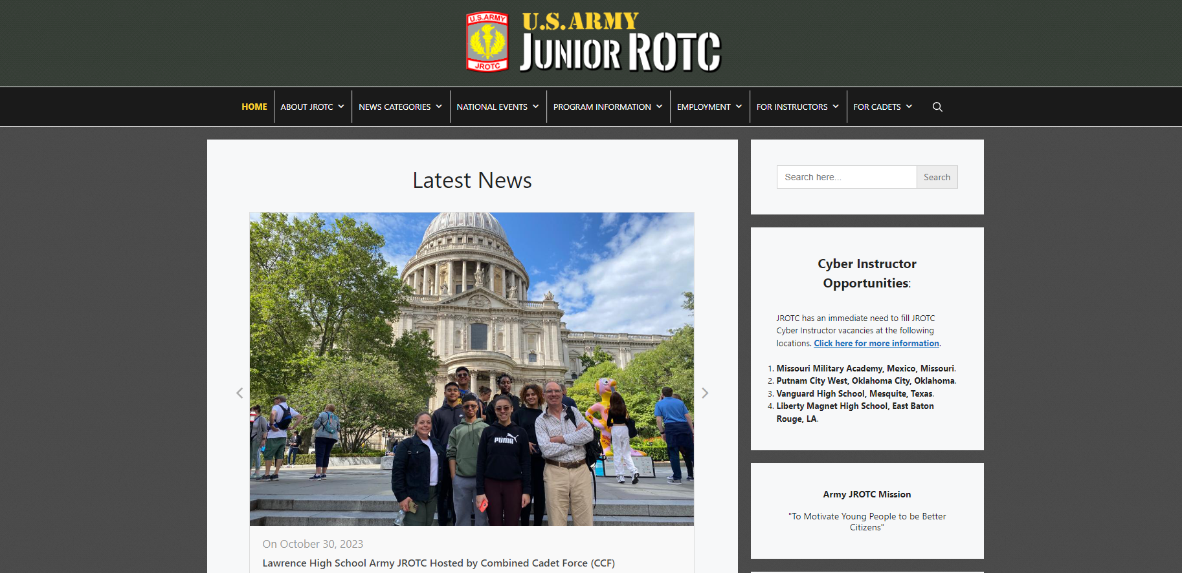
www.usarmyjrotc.com

The U.S. Army JROTC public website provides program information and resources to the public and USACC JROTC units worldwide. It includes the program’s history and purpose, national event information and photos, employment information and instructor vacancies, news stories, and recognition, extensive curriculum information and support documents for instructors, and resources for JROTC Cadets.

7-1 AUDIENCE
The web page’s audience includes educators, parents, Instructors, Cadets and potential JROTC Cadets, and all members of the public who want to learn about the program. In addition, current JROTC Cadets and Instructors benefit from the various resources and information presented.

7-2 CADET NEWS AND RECOGNITION
The webpage allows JROTC Instructors to recognize Cadets’ achievements and program activities on the national stage.

7-3 NATIONAL EVENTS
The webpage includes information, photos, and videos of the many exciting events that JROTC Cadets can experience. Visitors can learn about events such as the JROTC Leadership and Academic Bowl (JLAB), the National Raider Challenge, the VEX Robotics World Championship, CyberPatriot, the Air Rifle National Championship, the Archery Championship and the Army National Drill Team Championship.

7-4 EMPLOYMENT
The webpage includes information on the instructor application process, employment forms, CNACI process, pay calculator, instructor vacancies, and the latest employment news and alerts from the Army JROTC Instructor Management Division.

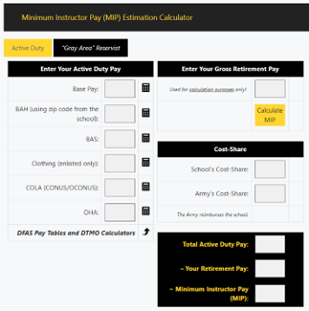
The JROTC Pay Calculator helps potential instructors estimate their pay and see the cost-share between the school and the Army.

7-5 INSTRUCTOR RESOURCES
This webpage section provides documents and information to support instructors in all areas of their program. This section includes curriculum download, instructor eLearning course information, technology support videos and helpdesk contacts, files and forms for equipment lifecycle and supplies, instructor best practices, safety documents, a library of U.S. Army forms and publications and downloadable posters and images for use in the classroom.

7-6 CADET RESOURCES
This webpage section includes downloads and resources on scholarship opportunities and tools such as MARCH2SUCCESS to assist with test preparation, essay contests, and a tool to organize the ribbons on their JROTC uniforms
7-7 POINT OF CONTACT
Chief, Training and Operations Division at 1-800-347-6641 or e-mail:
usarmy.knox.usacc.list.hq-jrotc-training-and-ops@army.mil.

7-8 REFERENCES
Army Regulation 145-2 and Cadet Command Regulation 145-2

INSTRUCTOR REFERENCES

The following references and documents are available on the JROTC website. These pages contain commonly accessed regulations, policies, and JSOCC course materials from U.S. Army JROTC and U.S. Army Cadet Command
JROTC Library ( https://usarmyjrotc.com/library/ )
U.S. Codes & Regulations
- Army Directive 2014-23 (Conduct of Screening and Background Checks for Individuals Who Have Regular Contact with Children in Army Programs)
- Department of Defense Instruction on JROTC, DODI 1205.13, (Feb 2006)
- JROTC Instructor Certification Memorandum (Jun 2007)
- Title 10 USC 2031: Junior Reserve Officers’ Training Corps (This section addresses enrollment requirements)
- Title 10 USC 2032 Junior ROTC
- Title 10 USC 2033 Junior ROTC: Instructor Qualifications
- Title 10 NDCC 4651
- 10 USC 2035 Junior ROTC: Flexibility in authorities for management of programs and units
Army Regulations
- AR 145-2 Junior Reserve Officers’ Training Corps Program: Organization, Administration, Operation, and Support (28 APR 2023).
- To view additional Army Pubs and Regulations, visit http://www.apd.army.mil.
Advanced Enlistment Grades ETP
- APS 20-03 – Advanced Enlistment Grades ETP (25 March 2020)
United States Army Cadet Command (USACC) Regulations
- CCR 145-2 – Organization, Administration, Operations Training and Support (12 AUG 2022)
  - JROTC Coaching Rubric
  - Abbreviated Instructor Medical Report
  - JROTC Instructor Counseling System
- CCR 145-8-3 – JROTC Program for Accreditation (JPA) 29 SEP 2021
- CCR 145-8 – ROTC Organizational Inspection Program
- CCR 385-10 – Cadet Command Safety Program
- CCR 670-1 – Uniform Wear and Appearance
- CCR 672-5-1 – ROTC Awards and Decorations
- Encl 1 to USACC Reporting SOP – USACC SIR incident matrix
- Serious Incident Report (SIR) Form
United States Army Cadet Command (USACC) Policy Letters
- To view Cadet Command Policy Letters, visit: https://www.cadetcommand.army.mil/forms_pubs.aspx
Cadet Command Forms and References
- JROTC Curriculum Guide v11
- CCF 134-R – Cadet Training Certificate (.pptx)
- CCF 146-1-R – Clothing/OCIE Property Record
- CCF 194-R – Inventory Control Listing
- CCF 211-R – Report of Medical Examination for JROTC Instructors
- CCF 219-R – Service-Learning Credit
- CCF 36-R – U.S. Army Enlisted Ranks/U.S. Army JROTC Enlisted Ranks
- CCF 37-R – U.S. Army Officer Ranks/U.S. Army JROTC Officer Ranks
- CCF 385-1-R – Composite Risk Management Worksheet
- JROTC Cadet Leadership Challenge (JCLC) Blank Reporting Form
- JROTC Cadet Leadership Challenge (JCLC) Checklist (.doc)
- JROTC Instructor Certification Directive Memorandum – (NDAA DoD Written Guidance)
- Request for Purchase
Common Table of Allowances
- CTA 50-900 – Clothing and Individual Equipment
- CTA 50-909 – Field and Garrison Furnishings and Equipment
- CTA 50-970 – Expendable/Durable Items

JSOCC Course Documents ( https://www.usarmyjrotc.com/jsocc-basic-course/ )
Basic Course Briefings
- 00 Introductions and Course Expectations
- 01 Instructor Management Brief
- 02 Director’s Brief
- 03 Title IX and Ethics
- 04 Best Practices
- 05 JSOCC Basic PH2 Capstone Rubric
- 06 Effective Teaching - Teaching Methods
- 07 CMv3 Training
- 08 JUMS
- 09 Cadet Portfolio
- 10 Effective Teaching - Classroom Management
- 11 Scholarship Brief
- 12 EI and Conover Online
- 13 IG Brief
- 14 REC Robotics
- 15 Archery NASP Brief
- 16 USAREC Brief
- 17 CyberStart Brief
Advanced Course Briefings
- 00 Introductions and Course Expectations
- 01 Instructor Management Brief
- 02 Director’s Brief
- 03 Title IX and Ethics
- 04 Best Practices
- 05 EI and Conover Online
- 06 CMv3 Refresher
- 07 Cadet Portfolio
- 08 JROTC Problem Solving
- 09 REC Robotics
- 10 USAREC Brief
- 11 MJC_SMC Brief
- 12 IG Brief
- 13 CyberStart Brief
Documents
- 01 Combined LET Classroom
- 02 NOCTI (CTE)
- 03 JSOCC Basic PH2 Capstone Rubric
- 04 SMART Cadet & CMv3 Account Creation Info Sheet
- 05 Google-Translate Tutorial
Manuals
- 01 JROTC Curriculum Guide v11
- 02 CMv3 User Manual
- 03 JROTC Instructor Protocols
- 04 Ethical Decision-Making and Key Legal Terms
- 05 Procedures to Order CMv3 Books from GPO
- 06 USACC JROTC Program Guide for Administrators 16DEC2022
- 07 JUMS User Guide

STEM AND CYBER Resources and Opportunities

Below is a list of open-source federal resources that Instructors may use as programs continue incorporating more STEM and CYBER education into the traditional JROTC curriculum.
STEM
- Department of Defense (DoD) STEM Opportunities- DoD STEM has opportunities for students of all ages, educators, and professionals.
https://www.dodstem.us/participate/opportunities

2. NASA STEM Engagement- In NASA STEM Engagement, we deliver tools for students and educators to learn and succeed. We seek to:
  - Create unique opportunities for a diverse set of students to contribute to NASA’s work in exploration and discovery.
  - Build a diverse future STEM workforce by engaging students in authentic learning experiences with NASA’s people, content, and facilities.
  - Attract diverse groups of students to STEM through learning opportunities that spark interest and provide connections to NASA’s mission and work.

To achieve these goals, NASA STEM Engagement strives to increase K-12 involvement in NASA projects, enhance higher education, support underrepresented communities, strengthen online education, and boost NASA's contribution to informal education. The intended outcome is a generation prepared to code, calculate, design, and discover its way to a new era of American innovation.

For Students
https://www.nasa.gov/stem/forstudents/9-12/index.html

For Educators
https://www.nasa.gov/education/materials/

3. Department of Education (DoE) STEM- The Raise the Bar: STEM Excellence for All Students initiative is designed to strengthen Science, Technology, Engineering and Mathematics (STEM) education nationwide.
https://www.ed.gov/stem

4. Other Federal Agency STEM websites- The following are federal agencies that the Department of Education collaborates with to support the aims of the STEM Education Strategic Plan and support the Department's stakeholders.

- Office of Science and Technology Policy (OSTP) and National Science and Technology Council (NSTC)
- STEM Education Advisory Panel
- Centers for Disease Control & Prevention (CDC)
- Environmental Protection Agency (EPA)
- Department of Agriculture (USDA)
- Department of Defense (DOD)
- Department of Labor (DOL)
- Bureau of Labor Statistics
- Department of Energy (DOE)
- NASA
- National Science Foundation (NSF) and NSF INCLUDES
- National Institutes of Health (NIH) (U.S. Department of Health and Human Services (HHS)
- National Initiative for Cybersecurity Education (NICE) at National Institutes of Standards and Technology (NIST) (U.S. Department of Commerce (DOC))
- National Oceanic and Atmospheric Administration (NOAA)
- Smithsonian Institute
- U.S. Geological Survey (USGS) (U.S. Department of the Interior)
- U.S. Patent and Trademark Office (USPTO) (U.S. Department of Commerce (DOC))
- U.S. Census Bureau – Statistics in School
- STEM4ALL - website for federal internships, scholarships, and training opportunities.
- Q-12 Education - K-12 quantum learning tools and inspire the next generation of quantum leaders.
- Quantum.gov - home of the National Quantum Initiative.
- AI.gov - National Artificial Intelligence Initiative.

CYBER
- US Cyber Challenge - US Cyber Challenge (USCC) is a program previously supported by the Department of Homeland Security’s Science and Technology Directorate through a contract with the Center for Internet Security, a 501c (3) organization. USCC serves as the premier program to identify, attract, train, recruit, and place the next generation of cybersecurity professionals into the workforce.
https://www.uscyberchallenge.org/

- National Initiative for Cybersecurity Careers and Studies (NICCS) - The National Initiative for Cybersecurity Careers and Studies (NICCS) website is the premier online resource for cybersecurity training, education, and career information. NICCS connects government employees, students, educators, and industry with cybersecurity resources and training providers throughout the Nation.
https://niccs.cisa.gov/

- CYBER.ORG - The academic initiative of the Cyber Innovation Center to empower educators to teach cyber confidently, resulting in students with the skills and passion needed to succeed in the cyber workforce.
https://cyber.org/

- Cybersecurity and Infrastructure Security Agency (CISA) - CISA is the operational lead for federal cybersecurity and the national coordinator for critical infrastructure security and resilience. They lead the national effort to understand, manage, and reduce risk to America’s cyber and physical infrastructure.
https://www.cisa.gov/
- Department of Education Office of Education Technology - The U.S. Department of Education recognizes the growing importance of addressing cybersecurity in educational settings. It provides various technical assistance for both K-12 and higher education. Multiple offices at The Department provide resources on cybersecurity, therefore this page will communicate information about the topic and curate resources in one place. Please note this page is not definitive or exhaustive and will be updated as new information and resources are developed.
https://tech.ed.gov/cyberhelp/

- US Department of Commerce-National Institute of Standards and Technology (NIST)-NICE - Previously known as the National Initiative for Cybersecurity Education, NICE now goes only by its acronym to reflect an institutionalized program working to advance cybersecurity education and workforce development. NICE is a partnership among government, academia, and the private sector focused on education, training, and workforce development that will strengthen the cybersecurity posture of organizations. They provide comprehensive lists and links to free, low-cost online cybersecurity learning content.
https://www.nist.gov/itl/applied-cybersecurity/nice/resources/online-learning-content

- National Security Agency/Central Security Service - NSA partners with schools to develop the talent and tools we need to meet future national security challenges by:

  - Funding skill development programs like summer camps
  - Promoting the development of curricula for growing career fields such as cybersecurity
  - Sponsoring skills and research paper competitions
  - Hosting student interns and co-ops
  - Awarding research grants and funding research labs and projects
  - Awarding Broad Area Announcement bid contracts through
  - NSA’s Acquisition Resource Center

These partnerships help cultivate the next generation of experts in science, technology, engineering, math, language, and analysis and broaden the pool of skilled cybersecurity professionals who can protect the nation from cyberattacks. Our academic partnerships also foster interest in the critical need for foreign languages and advance science through research and innovation benefiting the country, even beyond the NSA's need to apply emerging technologies to our mission.
We have partnership opportunities at both the college/university and kindergarten-12 level. If you are a student, an educator, or an academic researcher, we encourage you to check out our offer.
https://www.nsa.gov/Academics/

- National Geospatial-Intelligence Agency (NGA) - The High School Internship Program is for high school students ages 16 and older looking for real-world experience. The Internship Program will allow students to gain relevant work experience while contributing to an important and purposeful mission. Participants who graduate are eligible to apply for scholarship programs (i.e., the Undergraduate Scholarship Program, GEO-Scholar) offered by the NGA.
https://www.nga.mil/careers/Student_Opportunities.html
- National Cybersecurity Center - The National Cybersecurity Center offers free certification classes that can help you enter the world of cybersecurity and earn a living doing something challenging, viable, and sustainable well into the future.
https://cyber-center.org/three-cybersecurity-pathways-for-high-school-students/

- Cybersecurity Youth Apprenticeship Initiative (CYAI) - The Cybersecurity Youth Apprenticeship Initiative (CYAI) is funded by the U.S. Department of Labor’s (DOL) Employment and Training Administration (ETA) Office of Apprenticeship (OA). CYAI promotes sustainable development of cybersecurity apprenticeship programs for youth aged 16–21. The goal of the initiative is to create at least 900 new cybersecurity apprenticeships for youth by 2024.
https://cyai2024.org/

- Cybersecurity Guide - This guide serves as a guide for students interested in learning more about the cybersecurity field. They also cover tips for parents to help get their children involved in cybersecurity and teach them to be safe while browsing online.
https://cybersecurityguide.org/resources/k-12-guide/

- DoD Cyber Scholarship Program (DoD CySP) - The DoD CySP is sponsored by the DoD Chief Information Office and administered by the National Security Agency (NSA). The objectives of the program are to promote higher education in all disciplines of cybersecurity, to enhance the Department’s ability to recruit and retain cyber and IT specialists, to increase the number of military and civilian personnel in the DoD with this expertise, and ultimately, to enhance the nation’s cyber posture. As a recruitment tool, the DoD CySP sponsors students who are not DoD or government employees enrolled in or applying to universities designated as a National Center of Academic Excellence in Cybersecurity. Following graduation, students are eligible for full-time employment with various components and agencies across the DoD. Students are required to work for the DoD for a minimum of one year for each year of scholarship support they receive.
https://public.cyber.mil/wid/cdp/dcysp/

- US Army Cyber Command (ARCYBER) - U.S. Army Cyber Command (ARCYBER) is the supporting Army headquarters under the United States Cyber Command. They operate and defend Army networks and deliver cyberspace effects against adversaries to defend the nation with over 16,500 Soldiers, civilians, and contractors working 24/7 across the globe. Cybersecurity resources they can provide:
https://www.arcyber.army.mil/Resources/Fact-Sheets/Article/2059092/cybersecurity-resources/

LAWS, REGULATIONS AND DIRECTIVES

National Defense Act 1916 – Established concept of citizens’ Army; merged NG, AR, and RA into the Army of United States; presented military instruction to Officers at colleges and universities (ROTC); and organized JROTC at all other public or private educational institutions
The ROTC Revitalization Act of 1964 – Directs military departments to establish JROTC at qualified secondary schools. Established 2- and 4-year programs for Officers at colleges and universities
U.S. Code, Title 10, Section 2031 – Outlines Junior Reserves Officers’ Training Corps for all services. It is the purpose of the Junior Reserve Officers’ Training Corps to instill in students in United States secondary educational institutions the values of citizenship, service to the United States, personal responsibility, and a sense of accomplishment
U.S. Code, Title 10, Section 2031 – Fair & Equitable – Calls for a fair and equitable distribution of JROTC programs across the nation
Department of Defense Instruction 1205.13, Junior Reserve Officers’ Training Corps Program (21 May 21) – Updates responsibilities and procedures for the organization and administration of the JROTC program
Army Directive 2014-23, Conduct of Screening and Background Checks For Individuals Who Have Regular Contact With Children in Army Programs (10 Sep 14) – Childcare National Agency Check and Inquiries (CNACI) background investigations are required for all individuals who have regular contact with children under 18 years of age.
AR 145-2, Junior Reserve Officers’ Training Corps Program: Organization, Administration, and Support (28 APR 23) – Guiding regulation for Army JROTC program.
CCR 145-2, Junior Reserve Officers’ Training Corps Program: Organization, Administration, Operations, Training, and Support (12 Aug 22) – Guiding regulation for Army JROTC program.

ACRONYMS AND ABBREVIATIONS

AI
Army Instructor

AR
Army Regulation

C/ASU
Cadet Army Service Uniform

CCR
Cadet Command Regulation

CLE
Community Leaders and Educators

CM
Curriculum Manager

CNACI
Child Care National Agency Check and Inquiries

DA
Department of the Army

DAI
Director of Army Instruction

DL
Distance Learning

DD
Department of Defense

DoD
Department of Defense

DODI
Department of Defense Instruction

HQDA
Headquarters, Department of the Army

JCLC
JROTC Cadet Leadership Challenge

JCIMS
JROTC Command and Information Management System

JLAB
JROTC Leadership and Academic Bowl

JPA
JROTC Program for Accreditation

JUMS
JROTC Unit Management System

LET
Leadership Education and Training

MIP
Minimum Instructor Pay

MPS
Military Property Specialist

NDAA
National Defense Authorization Act

NDCC
National Defense Cadet Corps

OCP
Operational Camouflage Pattern

OML
Order of Merit List

JROTC
Junior Reserve Officers’ Training Corps

LET
Leadership Education and Training

MPS
Military Property Specialist

NDCC
National Defense Cadet Corps

SAI
Senior Army Instructor

SIR
Serious Incident Report

STEM
Science, Technology, Engineering and Mathematics

USACC
United States Army Cadet Command

JROTC NEW Instructor Priorities of Work (Example)
ADMIN TASKS | POC
Sign for Keys | School POC
Sign for School Laptop | School IT
Sign for Govt Laptop | JROTC S4
Test Passcode (in Gym Locker Entrance) | Any JROTC Instructor
Obtain JROTC T-shirts | JROTC S4 or DAI
Purchase JROTC Polo shirts | Local established vendor
Familiarize with budget control procedures | SAI
Familiarize with Fire Drill, etc. procedures | Any JROTC Instructor
Review new teacher requirements | School POC
Begin JROTC Instructor Portfolio Book | Any JROTC Instructor
Familiarize with school district digital platforms (grading, attendance, discipline, Lesson Plans, etc.)
WEEK 1 | POC
Test User/Password/Wi-Fi on Laptops | School IT
Set-up personal desk | Cadet S4
Configure classroom and review wall/info boards | Cadet S4
Test A/V Equipment | School IT / Cadet S4
Set-up Key Ring (color-code your keys) | Any JROTC Instructor
Familiarize with Instructor Resource’ (Common Drive) | S6
Practice and familiarize with CMV3 operations and lesson plans | Any JROTC Instructor
Familiarize with Top Staff Cadet’s and Special Staff Cadet names | Cadet S1
SCHOOL TRAINING / CERTIFICATION REQUIREMENTS
Active Shooter
Ethics
Diversity Awareness
Staff to Student
Asbestos Awareness
Bloodborne Pathogens
Bullying
Safety Data Sheets
Hazardous Communications
Fire Extinguisher Safety
U.S. ARMY TRAINING REQUIREMENTS
Ethics
Cyber Security
Contemporary American Education
JROTC Basic Course Online (20 Hours)
Civilian Marksmanship *
*Not required unless coaching Marksmanship
SPECIAL TEAMS PREPARATION
Review special team budget
Familiarize with recruiting best practices
Familiarize with calendar of practices and competitions
Review competition rules and safety concerns
Review MOI for upcoming SY competitions
Familiarize with equipment storage locations and inventory
Familiarize with practice/training/conditioning concepts

Army JROTC Co-Curriculars

An essential element of the JROTC curriculum is its co-curricular activities that help to build Cadet teamwork, confidence, and leadership. Cadets apply classroom learning to practical applications through co-curricular activities. Every JROTC program must have a Color Guard, a JROTC Leadership and Academics Bowl (JLAB) Team, plus at least one other co-curricular activity, such as a Drill Team, Raider Team, Air-Rifle Team, Robotics Team, Archery Team, Cybersecurity Team or Cadet Challenge Team. Further details are explained in USACC Reg 145-2, dated 12 August 2022.
- JROTC Cadet Leadership Challenge - The JROTC Cadet Leadership Challenge (JCLC) is an outstanding program of instruction that provides JROTC Cadets an opportunity to practice leadership skills, team building, and adventure training in a hands-on military environment.

The objectives of the JCLC are to:

(1) Provide Cadets an opportunity to practice leadership skills in an unfamiliar
environment.
(2) Allow Cadets a chance to participate in citizenship-building exercises.
(3) Allow Cadets to experience living and interacting with peers from other units in a military setting.
(4) Instruct leadership-type skills to Cadets in a hands-on military type of environment.
(5) Provide an opportunity to participate in adventure training not normally available to Cadets.
(6) Take advantage of recreational facilities and to have fun.
Training activities are categorized into Core, Integrated, and Optional events.
(1) JCLC Core Training.
a. Rappel Training
b. Map reading/land navigation
c. Aquatic activity
d. Physical Fitness Training
e. Team Building
f. Awards/graduation ceremonies

(2) Integrated training activities. Training executed throughout JCLC.
a. Physical training may include Cadet Challenge events
b. Field sanitation/personal hygiene
c. Leadership training
d. Drill and ceremonies
e. Prevention of heat injuries
f. Prevention of cold weather injuries

(3) JCLC Optional Training
a. STEM/Cyber Science Modules
b. Leadership Reaction Course
c. Confidence/Obstacle Courses
d. Cadet Civilian Marksmanship and Safety Program
e. Survival skills/Emergency Response Procedures
f. CPR Certification
g. Water rafting
h. Jump tower (34’ Tower utilized during Airborne Training)
i. Static displays
j. Alcohol/drug abuse class
k. Anti-bullying/suicide prevention/sexual harassment training
l. Orienteering
m. Archery (Using compound bows only with no more than 20 lbs. of draw)
n. High Ropes/Low Ropes course
o. Army Values
p. Rope bridges
q. Other organized activities: movies, swimming pool, Post Exchange, athletic competition, etc.

- Raider Challenge Team – The Raider Challenge is a JROTC competition that tests skill, strength, stamina, and teamwork across a set of outdoor adventure tasks.
The competition normally consists of the following five events:

(1) A physical team test comprised of negotiating obstacles, carrying equipment for short distances, and running a prescribed distance.
(2) A five-kilometer team run.
(3) A cross-country hill run called the Gauntlet can include obstacles such as walls, tunnels, and tires.
(4) A cross-country rescue in which teams carry a dummy-laden litter over and under obstacles.
(5) The building and crossing of a one-rope bridge across a water obstacle or similar structure.

Alternate events may be implemented based on environmental conditions and the sponsoring command’s authorization. Teams may participate in Brigade-sponsored Raider Challenge competitions and the National Raider Challenge Championship competition. USACC is the sponsoring command for the National Raider Challenge Championship.

- JROTC Leadership and Academic Bowl (JLAB) - The JROTC Leadership and Academic Bowl (JLAB) is a premier event and is JROTC’s largest national high school leadership and academic competition. JROTC units may participate with two teams, an academic team and a leadership team. It is configured as a collegial/STEM event focused on improving SAT/ACT scores, increasing interest in college admissions, demonstrating academic and leadership strengths of JROTC programs, and boosting team and unit spirit. All Army JROTC units will participate in Level 1 of the competition with either an Academic or a Leadership team. Participation is recommended for first-year Army JROTC units; however, all Army JROTC units must participate in at least one of the competitions after their initial first year. Brigades will ensure maximum participation by units within their areas of operation.

- Drill ceremonies and competitions - Drill and Ceremonies are one of the key ingredients of the Army JROTC Program. Drill will be conducted IAW current Army Training Circular 3-21.5, Drill and Ceremonies, dated 3 May 2021, which is the Army standard for executing the Manual of Arms. This category also includes an Exhibition drill following brigade-published standards. Teams may participate in Brigade-sponsored Drill competitions, in the Army National Drill Team Championship competition and the All-Service National Drill Team Championship competition.

- Archery - The Army JROTC program currently uses the National Archery in the Schools Program (NASP) as an established guideline for its archery program. Each school conducting an archery program must have its SAI or AI certified to conduct archery training IAW NASP standards and regulatory guidelines.

- Air Rifle / Civilian Marksmanship competitions - The military services have partnered with the Civilian Marksmanship Program (CMP) to conduct a quality and safe air rifle marksmanship program for its JROTC units.
It supports the following objectives:
(1) To instruct citizens of the United States in marksmanship.
(2) To promote practice and safety in the use of firearms.
(3) To strengthen confidence and competence in the use of firearms through participation in competitions and the award of trophies, prizes, badges, and other insignia to competitors.
The only authorized marksmanship training in JROTC is with the use of the air rifle and under the supervision of the JROTC instructors.
- Drones - Small Unmanned Aircraft System (sUAS) programs are authorized and must be established IAW Federal Aviation Administration (FAA) Recreational Flyer and Modeler Community-Based Organization guidelines, school principal approval, and parental consent. Submersibles are also a part of the drone program.

- VEX Robotics competitions – The Robotics Education and Competition Foundation sparks interest in science, technology, engineering, and math (STEM) by engaging in hands-on robotics programs. Robotics programs are authorized and may be established with school principal approval. JROTC Robotics programs are encouraged to register with VEX Robotics competitions.

- CyberPatriot - CyberPatriot is the premier national high school cyber defense competition designed to excite, educate, and motivate the next generation of cyber defenders critical to national security. The competition has a tournament-style structure with a series of web-based competition rounds, which culminate in the National Finals Competition annually.

- CyberStart - The JROTC CyberStart program enables Cadets to discover the field of cyber-security through gamified learning wherein they work through progressively harder levels of real-world challenges. Along the way, they learn programming, cyber defense, forensics, and more, all through independent experiential learning that does not require the instructor to play an active role beyond providing encouragement.

- Cadet Challenge - The overall goal of the JROTC fitness program is to improve Cadets’ strength, and cardiovascular endurance and promote a healthy lifestyle.

The Cadet Challenge provides a means to:
- Develop a separate identifiable physical fitness component.
- Build team spirit and unit esprit.
- Publicize JROTC in the school and the community.
- Demonstrate individual fitness as an important element of personal growth and development.

The Cadet Challenge consists of the following events:

- Curl-ups or partial curl-ups
- Pull-ups or right-angle push-ups (or flexed-army hang, but only for the National Physical Fitness Award).
- V-sit reach or sit and reach.
- One-mile run/walk.
- Shuttle Run.

No alternate events are authorized.

FORMS

DD Form 3200 JROTC Instructor Prohibited Activities Acknowledgement (NEW)

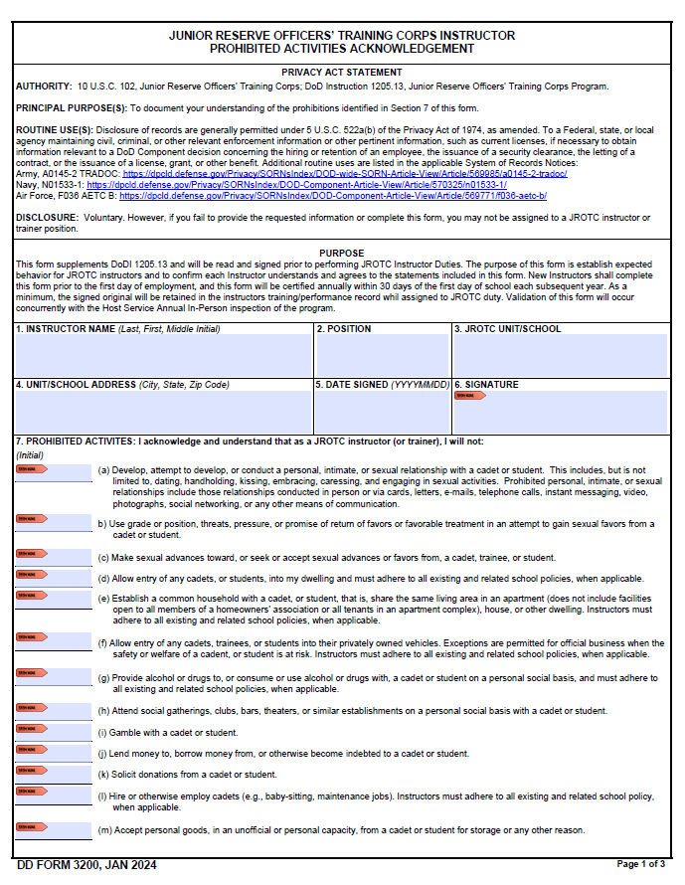
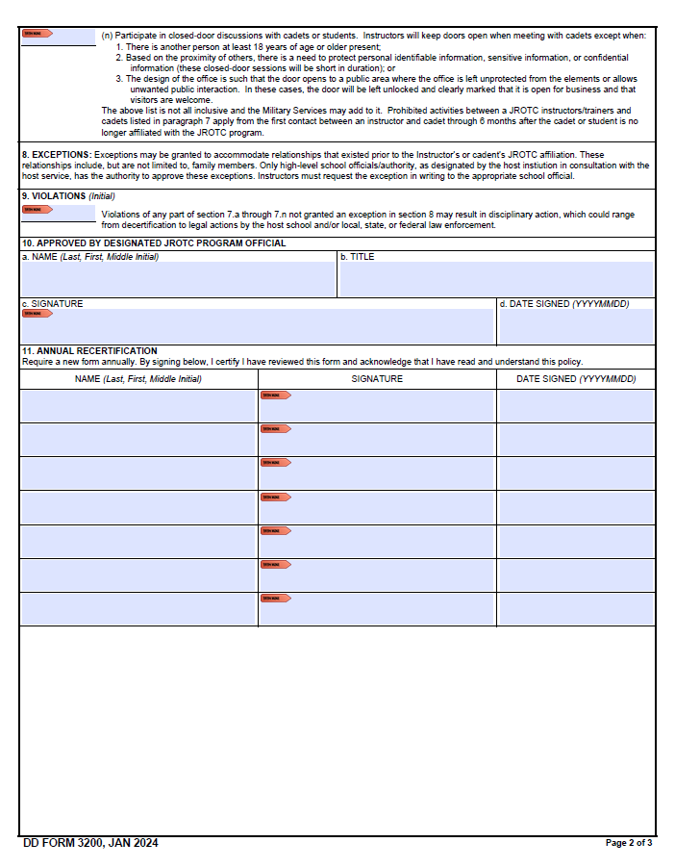
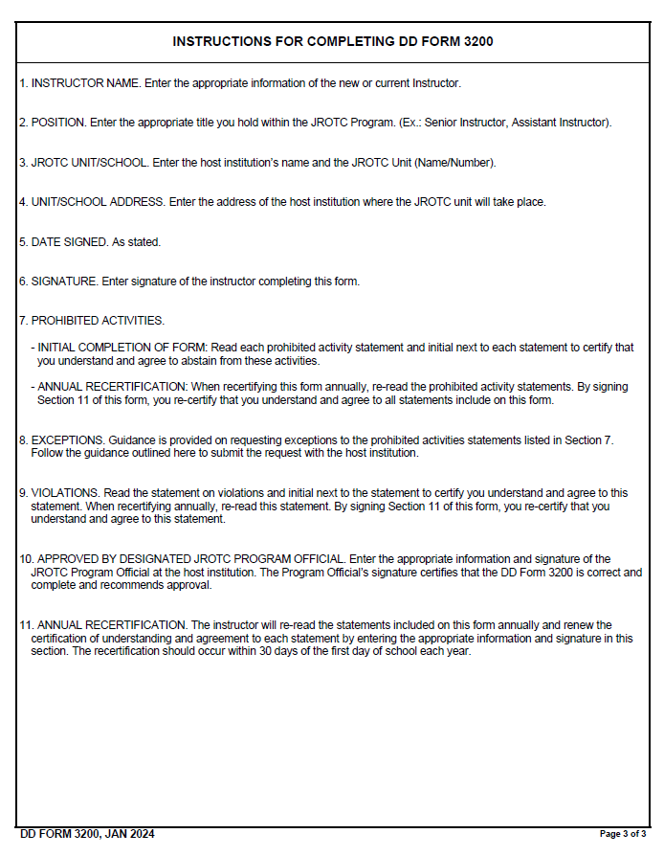

DD FORM 3202 Memorandum of Agreement Between Military Service and School District to Establish and Operate a JROTC Unit (NEW)
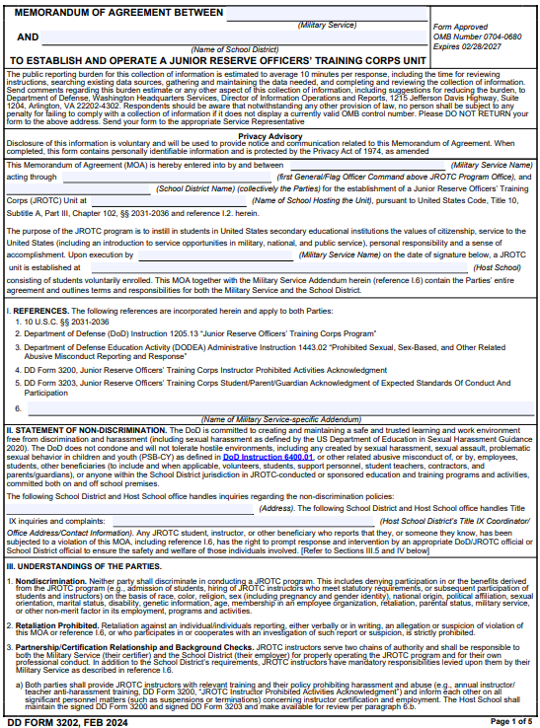
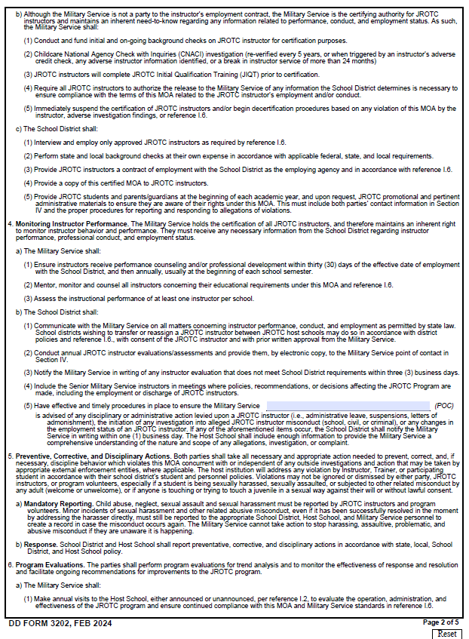
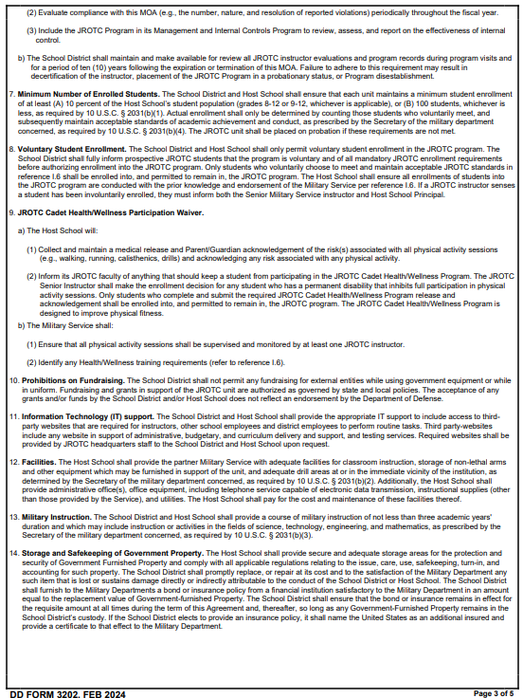

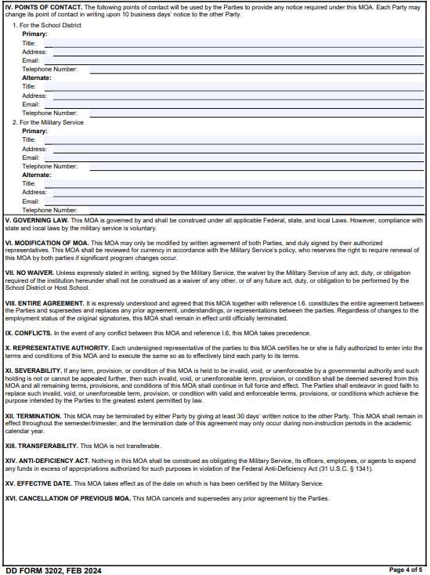

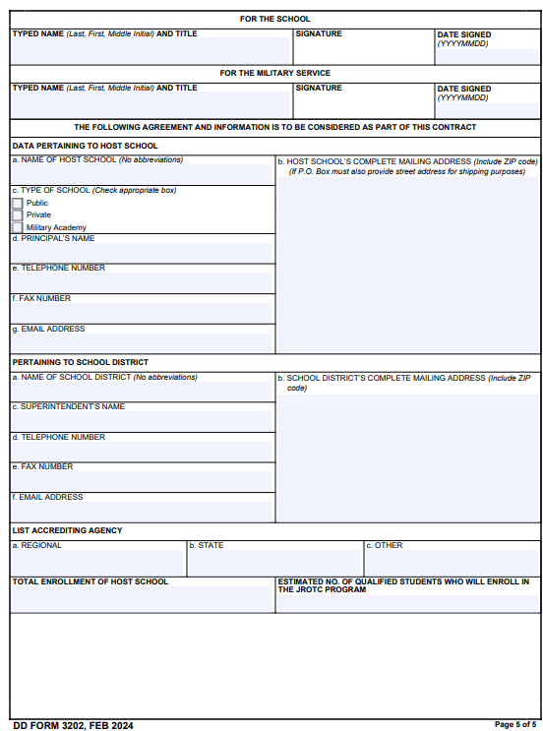

DD Form 3203 JROTC Student Code of Conduct and Parent/Guardian Consent Form (NEW)
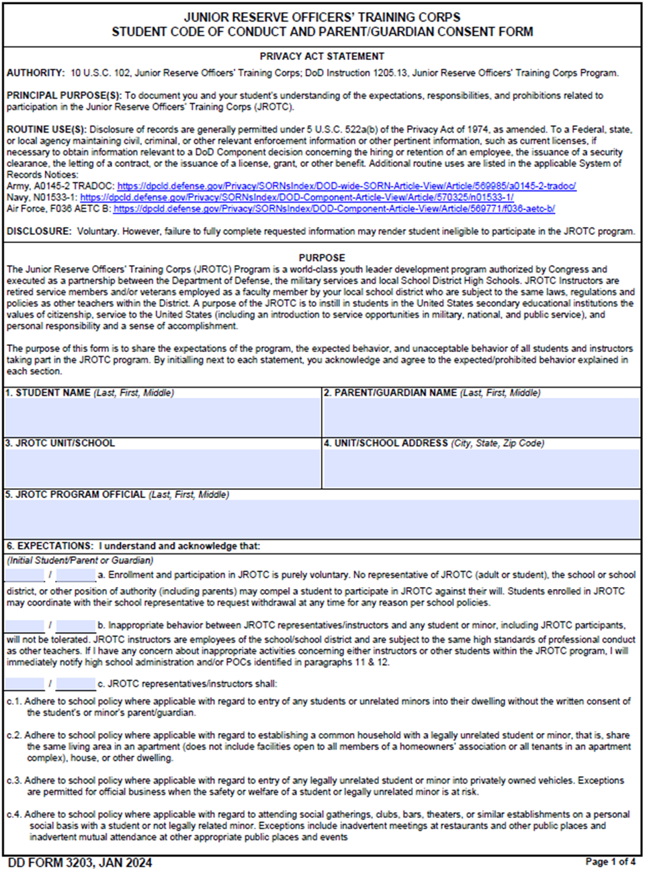
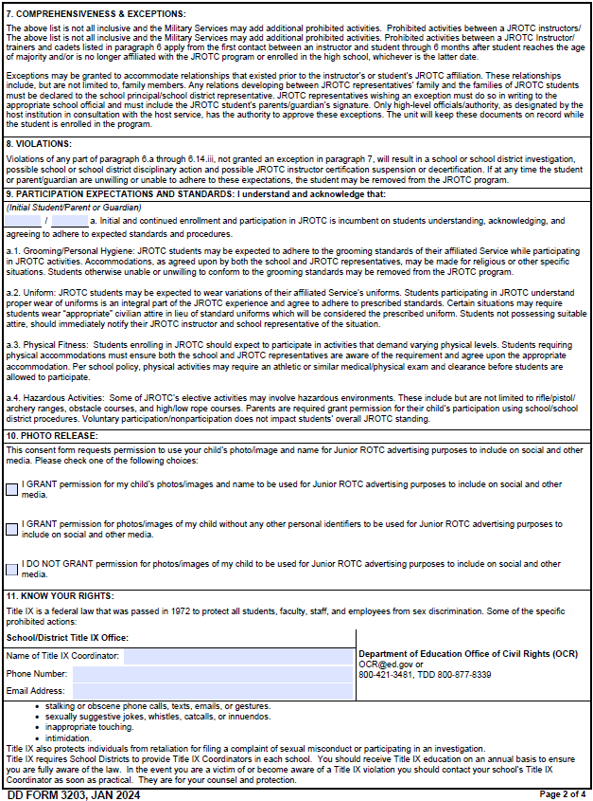
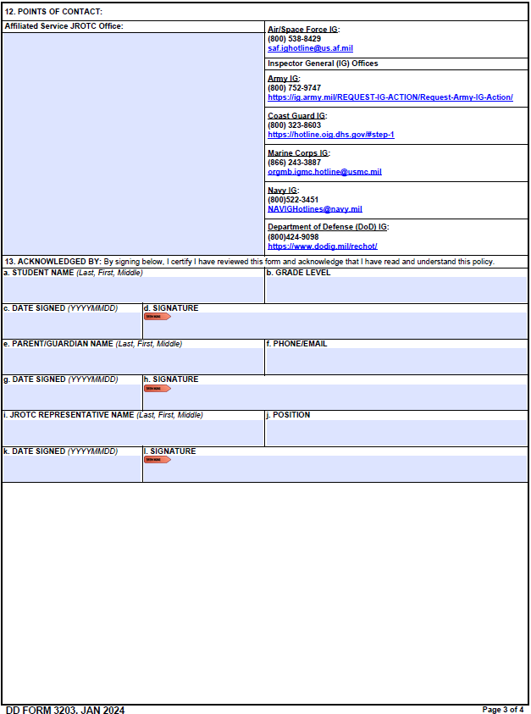
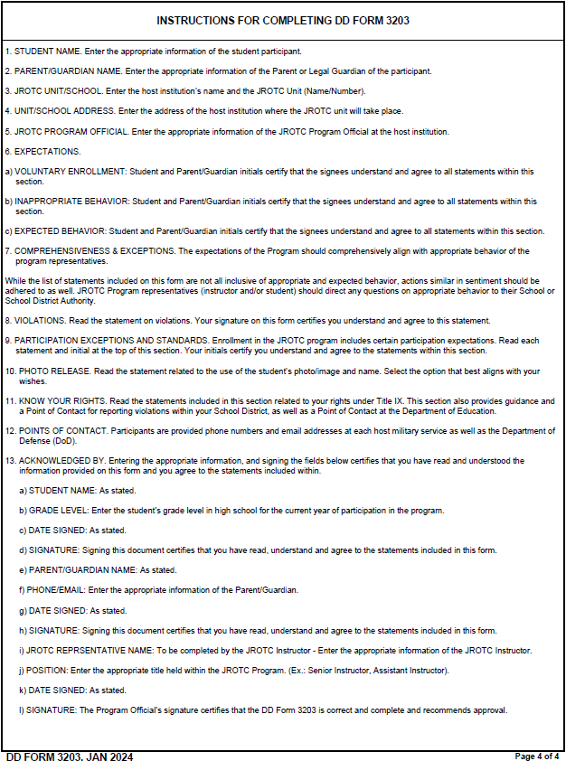

DA Form 3126 Application and Contract for Establishment of a JROTC Unit
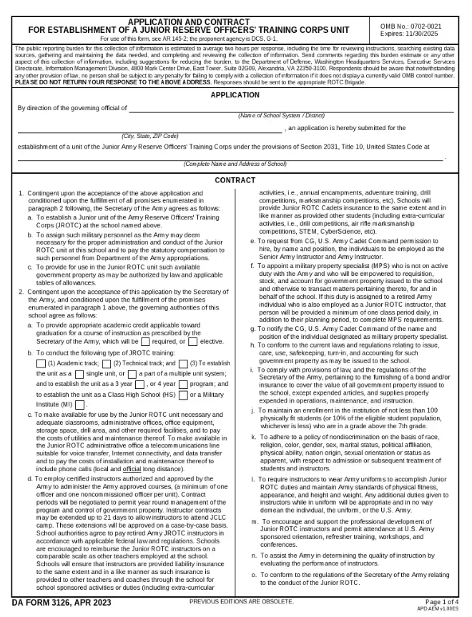
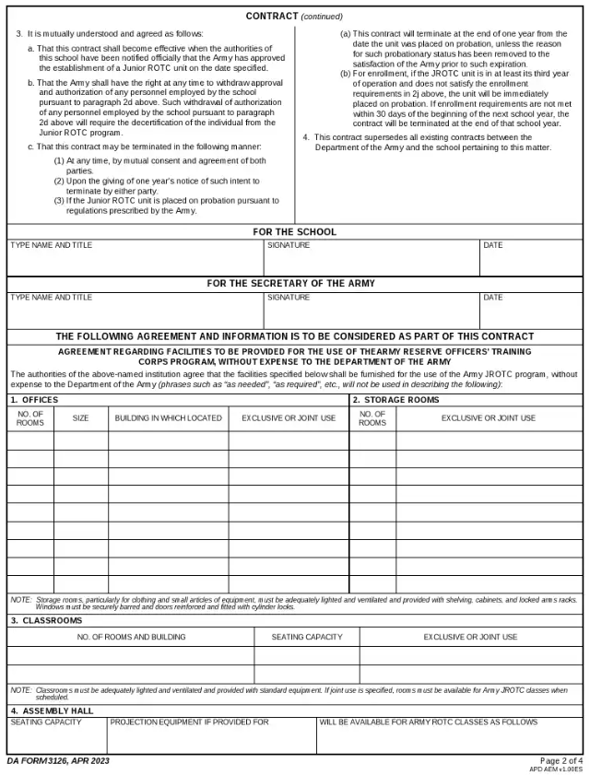

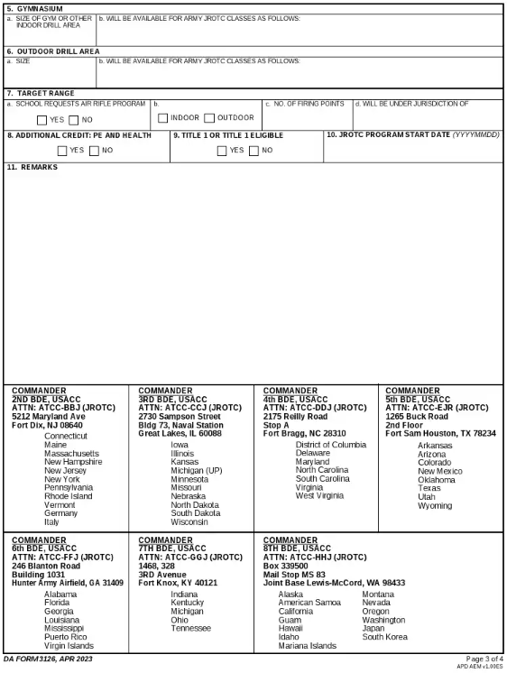

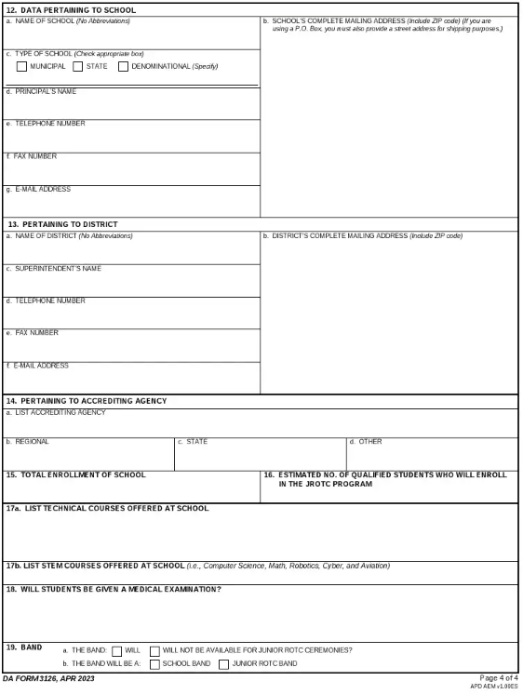

DA Form 3126-1 Application and Contract for Establishment of a National Defense Cadet Corps Unit
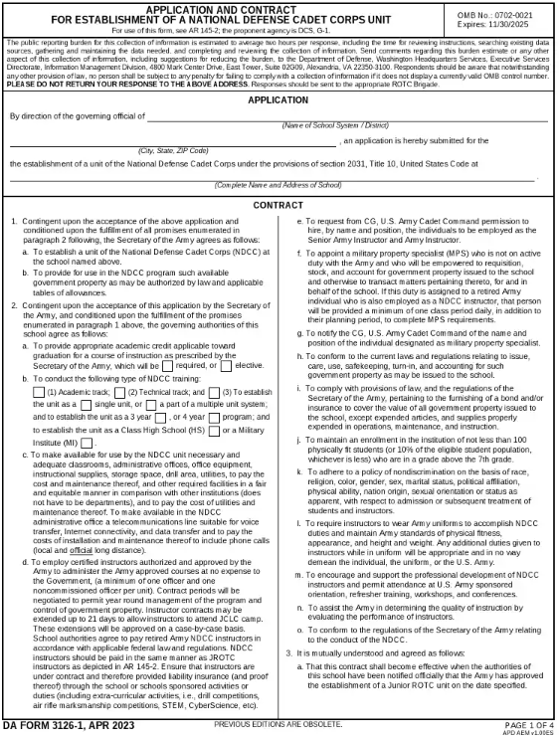
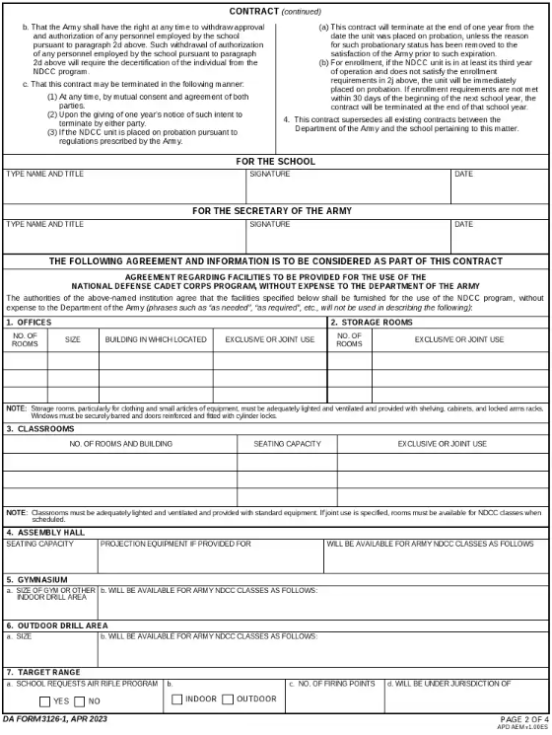
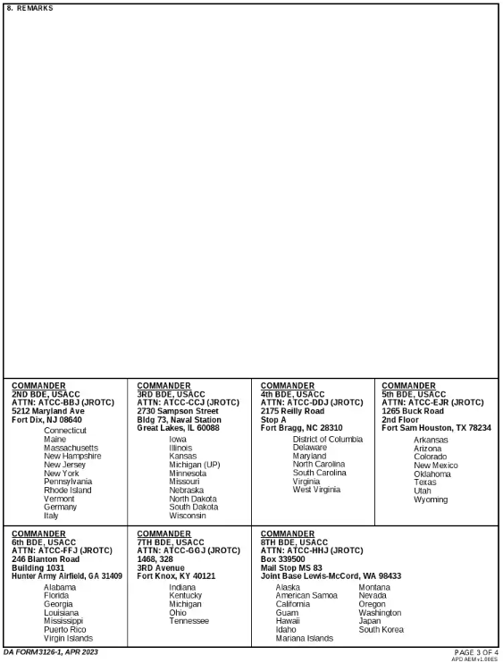

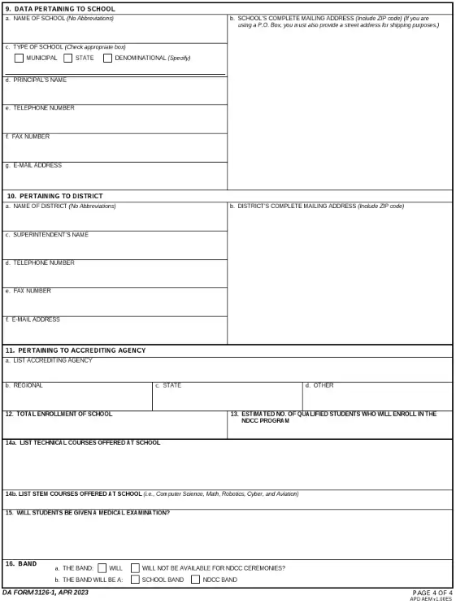

DA Form 7410 Evaluation Worksheet Potential Army JROTC Program
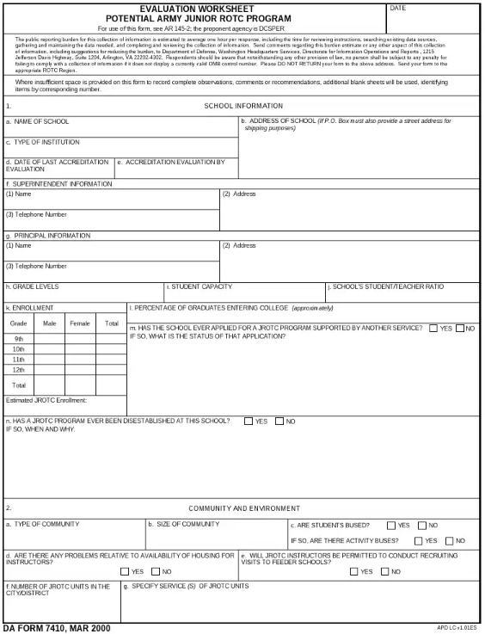
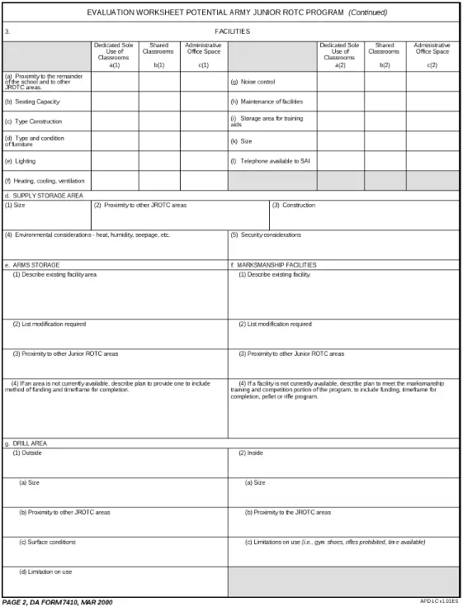

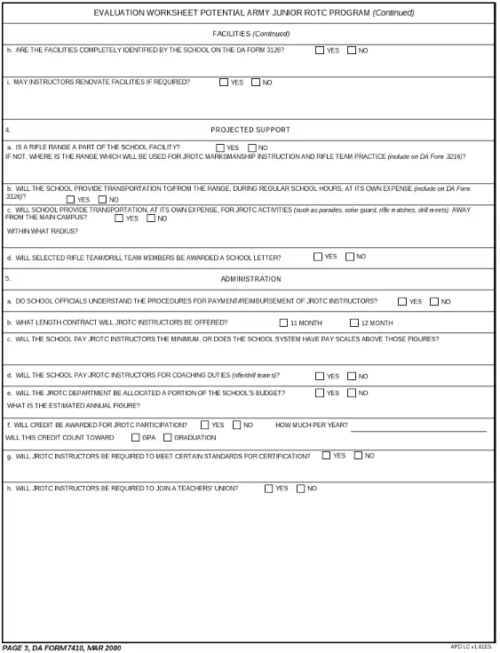

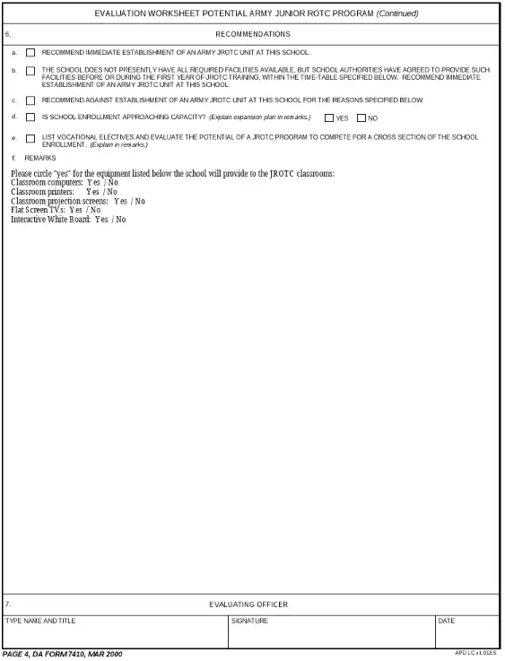

ARMY JROTC INSTRUCTOR CREED

Junior Reserve Officers’ Training Corps Instructor’s Creed

I am a Junior ROTC Instructor. My mission is to “Motivate Young People to be Better Citizens”.

I will teach, coach, and mentor each Cadet to reach their full potential academically, physically, and mentally.

I will provide opportunities for each Cadet to succeed and build pride in themselves, their school, and their community.

I will communicate with school administrators and parents/guardians in a timely and respectful manner.

I will protect Cadets from conditions harmful to learning or well-being.

I will guide each Cadet to meet and maintain personal standards and expectations for self-discipline and academic success.

I will live and demonstrate the Army values of loyalty, duty, respect, selfless service, honor, integrity, and personal courage in the performance of my duties.

I will work with all stakeholders to enhance the learning opportunities of our Cadets.

I will strive to enhance my classroom instruction and program management.

I will motivate Cadets “To Be All They Can Be”.

May God grant me the strength to always live by this creed.

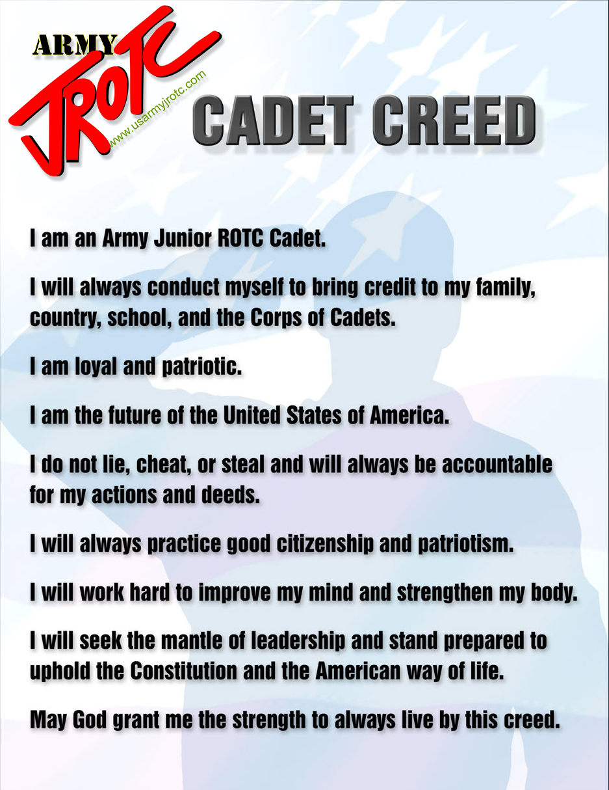

CADET CREED

