Medal of Heroism | Superior Cadet | Distinguished  Cadet  N-1-1 | Academic  Excellence  N-1-2 | Academic  Achievement  N-1-3
Perfect  Attendance  N-1-4 | Student  Government  N-1-5 | LET Service  N-1-6 | Enter Your  Award Name Here  N-1-7 | Enter Your  Award Name Here  N-1-8
Enter Your  Award Name Here  N-1-9 | Enter Your  Award Name Here  N-1-10 | DAI/SAI Instructor  Leadership  N-3-1 | Personal  Appearance  N-3-2 | Proficiency  N-3-3
Drill Team  N-3-4 | Orienteering  N-3-5 | Color Guard  N-3-6 | Rifle Team  N-3-7 | Adventure  Training  N-3-8

Enter Your  Award Name Here  N-3-14 | Enter Your  Award Name Here  N-3-15 | Varsity Athletics  N-2-1 | JROTC Physical  Fitness Award  N-2-2 | JROTC Athletics  N-2-3
Enter Your  Award Name Here  N-2-4 | Enter Your  Award Name Here  N-2-5 | Parade  N-4-1 | Recruiting  N-4-2 | Enter Your  Award Name Here  N-4-3
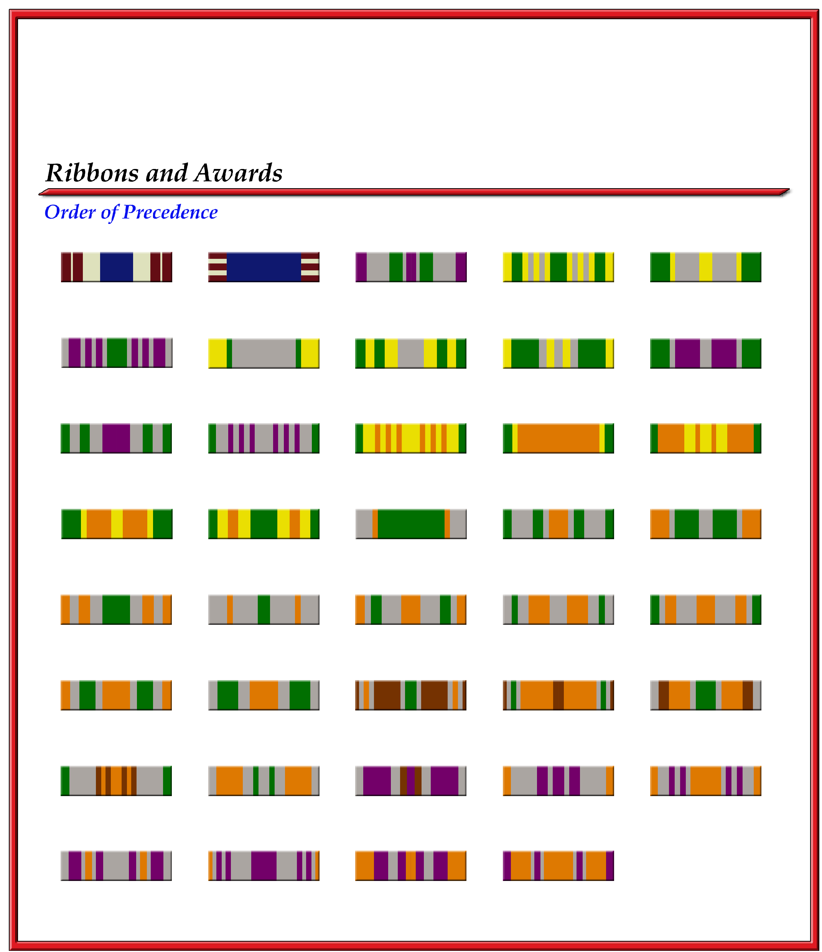
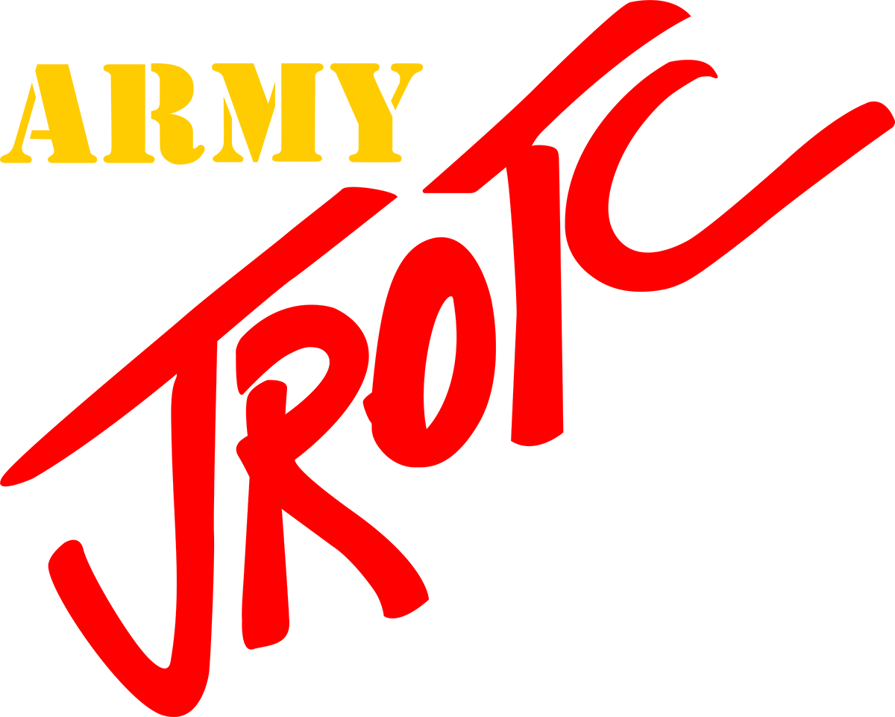
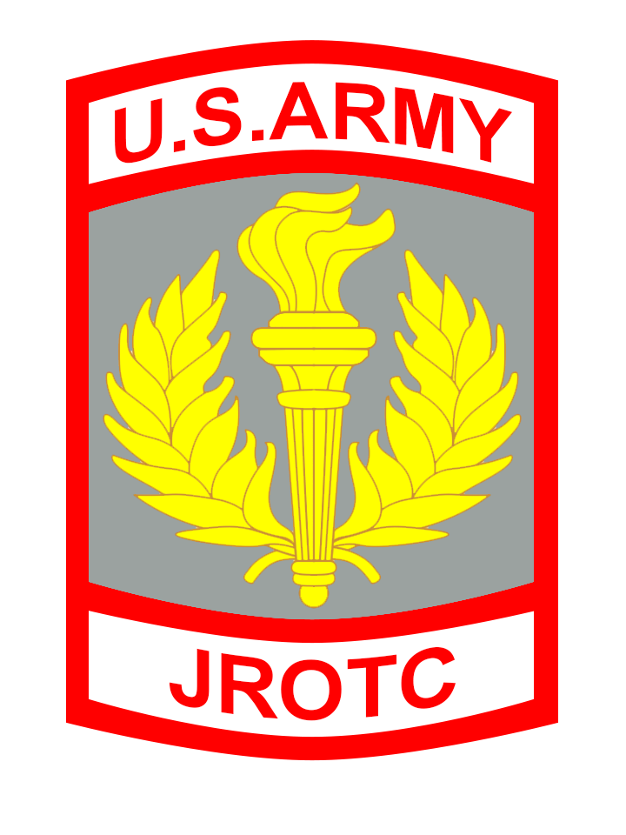
Enter School Name Here
Enter Your  Award Name Here  N-4-4 | Enter Your  Award Name Here  N-4-5 | Service Learning  N-4-6 | Excellent Staff  Performance  N-4-7
Commendation  N-3-9 | Good Conduct  N-3-10 | JCLC  N-3-11 | Enter Your  Award Name Here  N-3-12 | Enter Your  Award Name Here  N-3-13

