**Schoology Instructions:**

Step 1: Log In or Sign Up for account at Schoology.com



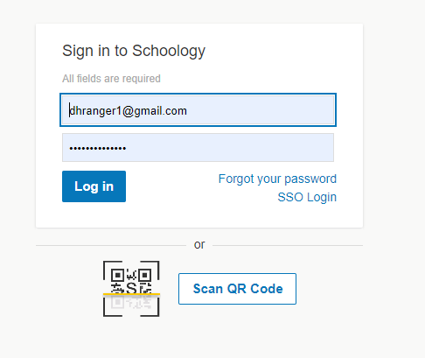

Step 2: Verify your account and select your school

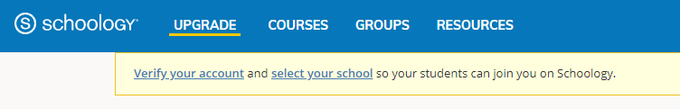

Step 3: Click on the Courses tab



Step 4: Click on the My Courses tab at the far right

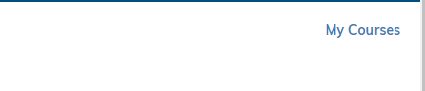

Step 5: Click on the Create Course tab

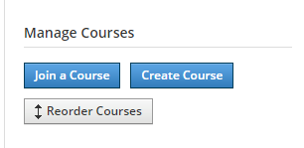

Step 6: Fill in the fields marked with *, then click Create

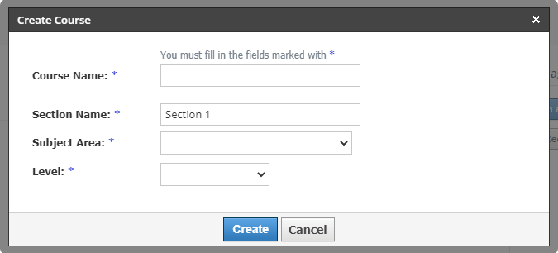

Step 7: Click on the Add Materials menu and choose from any of the options shown to begin creating your own online learning environment.

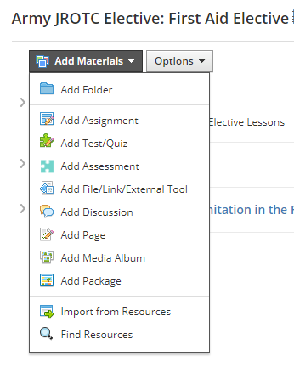

Step 8: Create a folder to hold your lesson material

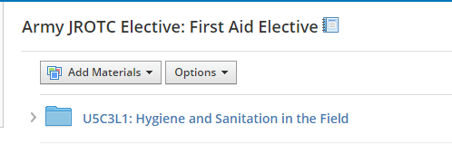

Step 9: Open your folder by clicking on it. For our purposes ‘Add Discussion’ seems to be the best choice, however feel free to explore other options

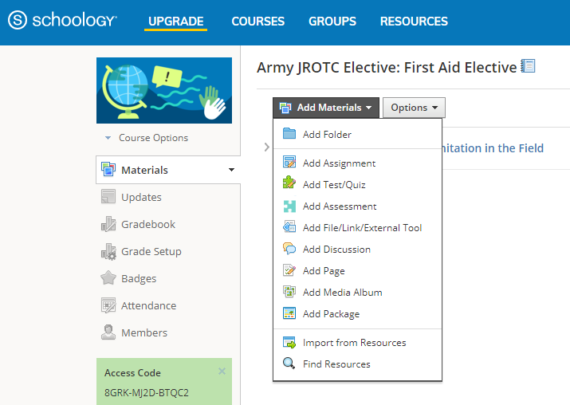

Step 10: With Google Classroom open to the lesson you want to transfer, begin to copy and paste the content over to Schoology. For this example, the material to transfer is **U5C3L1: Hygiene and Sanitation in the Field**.

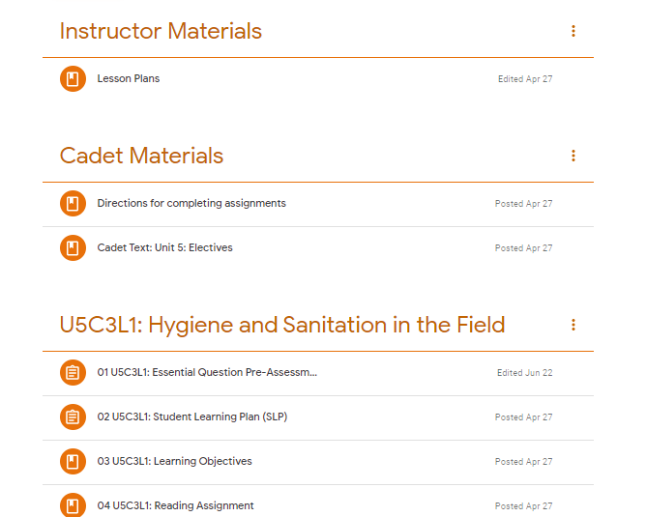

Step 11: Click on the 3 vertical ‘dots’ next to ’**01 U5C3L1: Essential Question Pre-Assessment** and then click on ‘edit’.

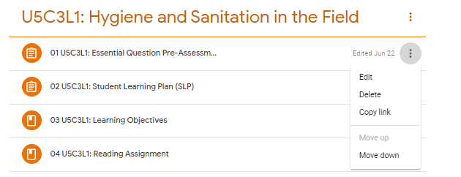

Step 12: Copy and paste the headings and directions straight out of Google Classroom and into Schoology.

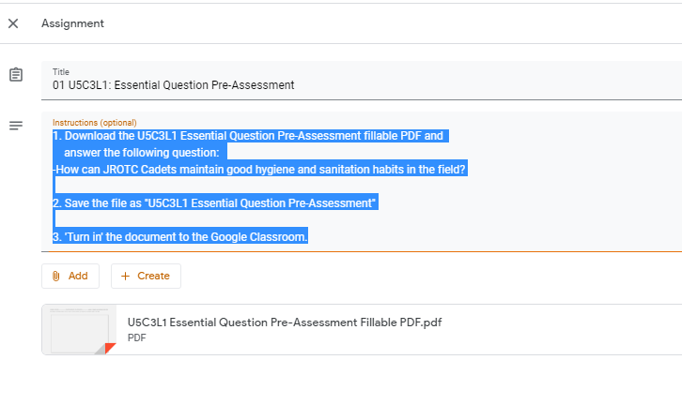

Before & After

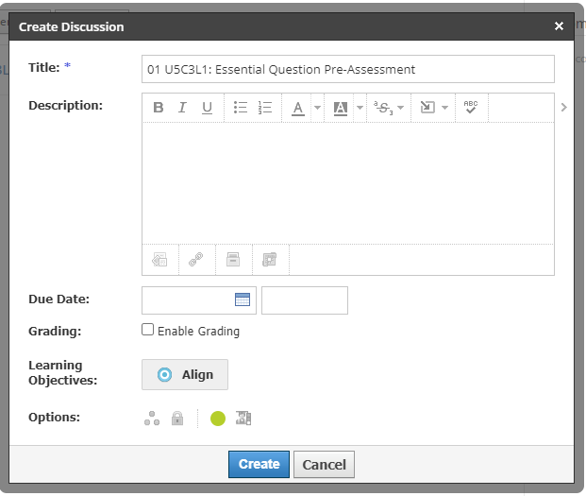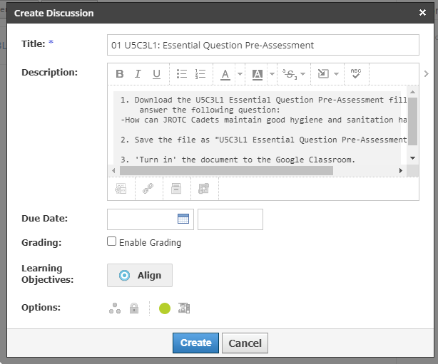

Step 13: Click on the ‘add file’ icon and add the U5C3L1 Essential Question Pre-Assessment Filliable PDF. Then click **Save Changes.**

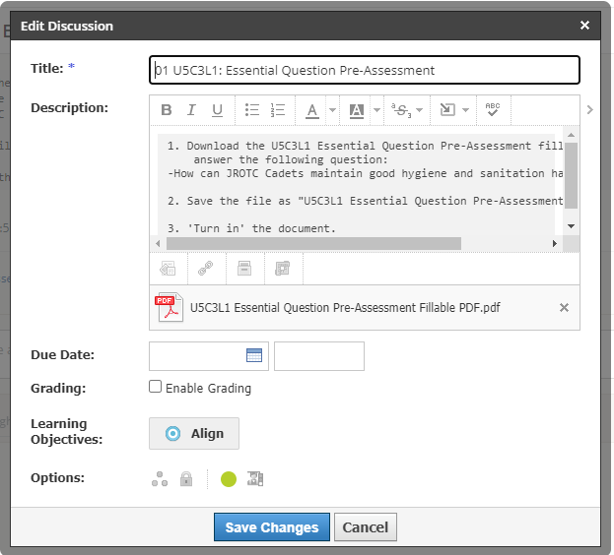

Step 14: Repeat the process for all documents in each lesson. __________________________________________________________________________________________________

Step 15: Creating an Assessment – click on ‘Grade Setup’ and then + Add.

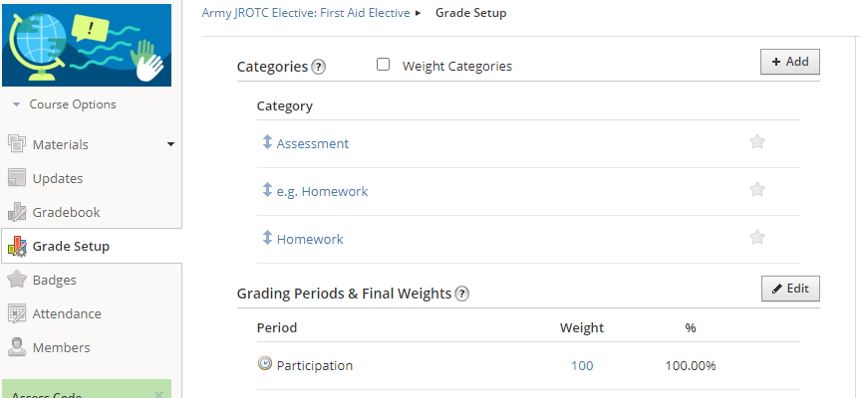

Step 16: Insert a category name and then click Create. For this example, we created the category of Essential Question Pre-Assessment.

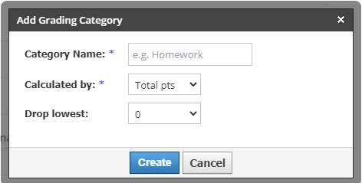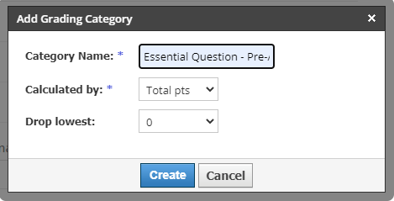

Step 17: In the U5C3L1: Hygiene and Sanitation in the Field folder click on Add Test/Quiz.



Step 18: Add the name of your assessment and assign it a category – we used the assessment category that was just created, then click Create.

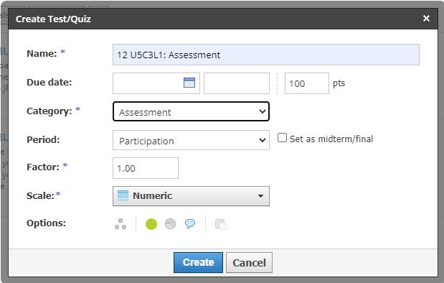

Step 19: Click on Add Question, we are using multiple choice for the example. Feel free to explore the various types available.

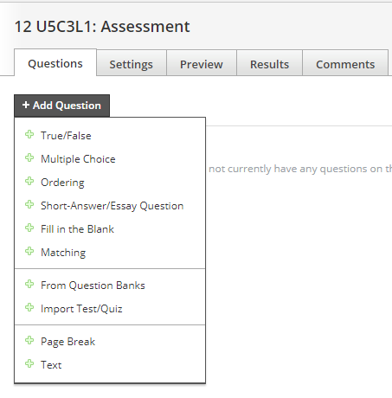

Step 20: Click on the Google Classroom file: 12 U5C3L1: Assessment – click on the 3 vertical ‘dots’ and choose edit.



Step 21: Click on the Google Form

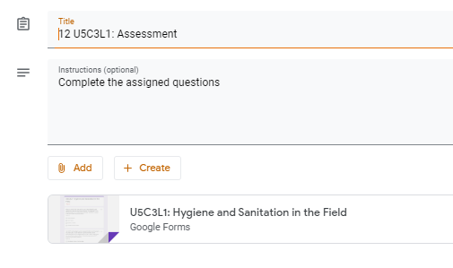

Step 22: On the bottom right click on the edit button

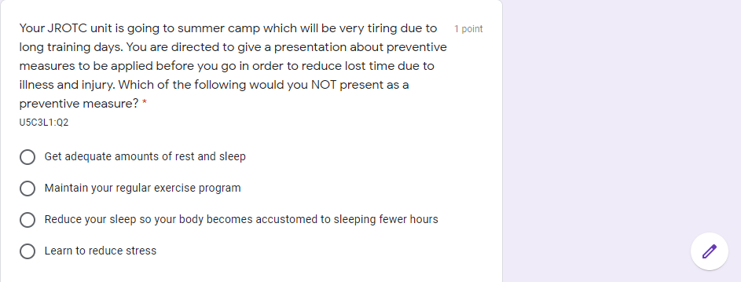

Step 23: Copy and paste the question and choices from the Google Classroom Assessment into Schoology.

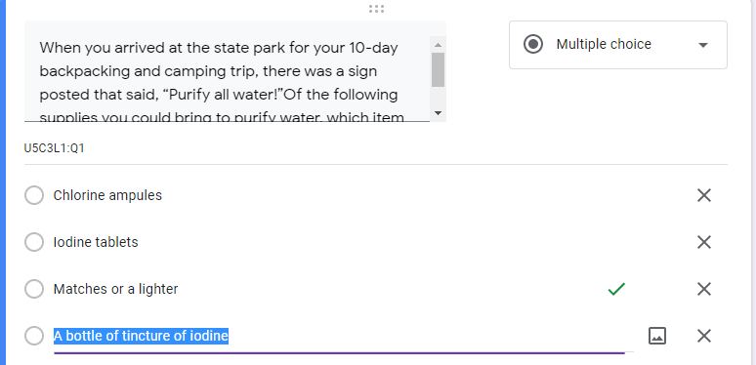

Step 24. Remember to select the correct answer and to randomize the order of the choices.

