Audience:

The intended audience is JROTC Instructors.

Goals and purpose:

The goals are to (1) provide Instructors with distance learning courses for use by their Cadets, (2) allow Instructors a means to structure and communicate these materials to their Cadets, and (3) give Cadets an avenue to return work to their Instructors for feedback.

Outline

1. Army JROTC Distance Learning Courses available via Google Classroom (Additional eLearning Lessons above and beyond these below is the responsibility of the Instructor to create)
   1. Curriculum materials included:
      1. 5-8 lessons per LET Level
         1. LET 1 – 8 Lessons
         2. LET 2 – 6 Lessons
         3. LET 3 – 5 Lessons
         4. LET 4 – 5 Lessons
         5. First Aid (Elective) – 8 Lessons
         6. Geography (Elective) – 7 Lessons
      2. Cadet Core Textbooks and Notebboks (LETS 1-4) and Unit 5 Elective Text
      3. Additional lesson resources, included:
         1. Student Learning Plans (SLP)
         2. Performance Assessment Tasks (PAT)
         3. Lesson Plans
         4. Thinking Maps© and graphic organizers
         5. ALL activities and exercises for included lessons
2. Access to Army JROTC Cadet Distance Learning Courses
   1. Requirements to access:
      1. Access is restricted to current Army JROTC Instructors, DAI Offices, and Brigade staff.
      2. A non-school Gmail account is necessary to gain access. The usarmyjrotc.com account will not work for these courses. **You must be signed out of all other Gmail accounts before accepting the invite.**
      3. From your non-school Gmail account request access with an email addressed to armyjrotcdlcourses@gmail.com
         1. You must include the following:
            1. Name/Rank
            2. School/District name
            3. LET Level(s) requested
      4. Your will receive an email invitation to co-teach, open the message.
      5. If you are a school that uses Google Classroom, you will have to pull the DL courses into your school’s domain.

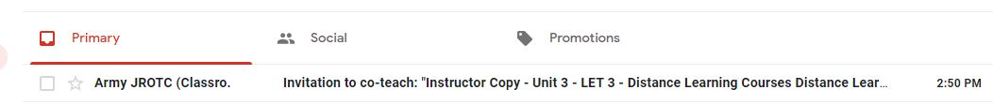

* + 1. Click join, and on the next screen accept.

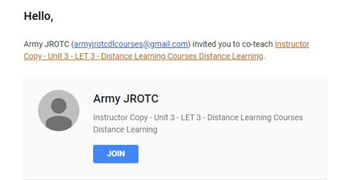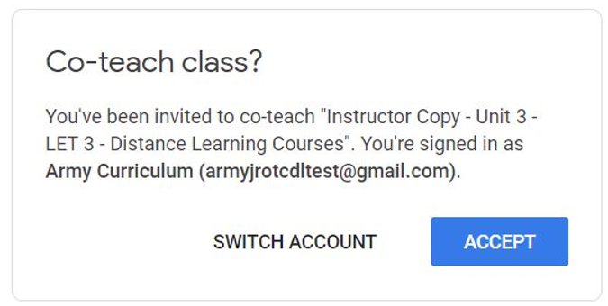

* + 1. Click continue.

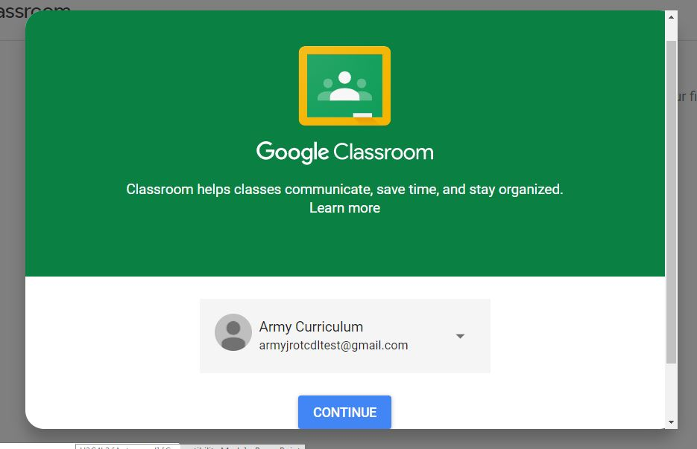

* + 1. The Distance Learning Courses have now been added to your Google Classroom for your use. Assign Cadets to your online class.

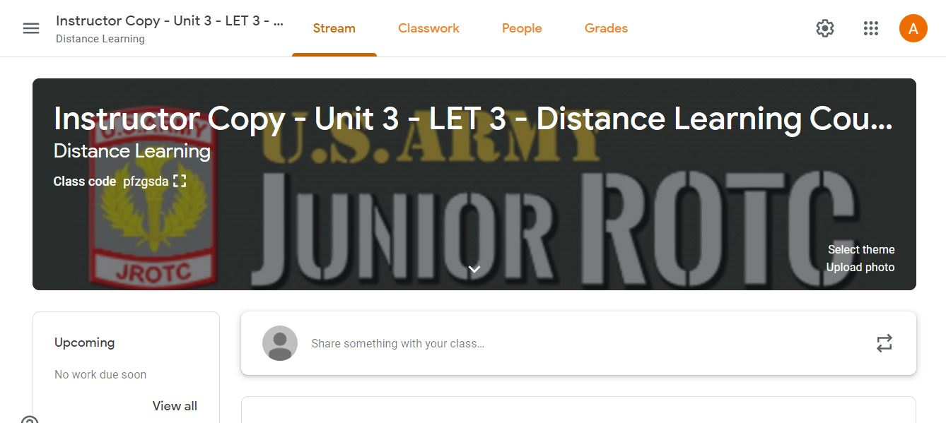

1. Trouble Shooting
   1. If you are missing any of the PDF documents from your copies of the courses you need to navigate to the url below:
      1. <https://drive.google.com/drive/folders/1tC-l_eaj3JtlvtER0Am42aAeFlq4VGEe?usp=sharing>
         1. Download/copy the document(s) and add it to your course(s)
         2. This link contains all of the PDF documents used in these Cadet Distance Learning courses
2. Options for the use of Curriculum materials
   1. Instructors should modify and adapt the curriculum to fit the requirements of their school districts and needs of their Cadets

**Recommended Example** (Requires work on Instructor to take these materials from classroom to online):

* + 1. Assign readings. Assign Lesson Activities/Exercises pulled from classroom Lesson Plan.
    2. Assign a deadline to read and post/publish their responses or documents.
    3. Provide a location for them to post/publish their assignments.
    4. Create an assessment using your LMS tools to administer online.
    5. Review, grade and provide feedback.
  1. The posting of these materials to school learning management systems (LMS) is intended for the use of Army JROTC Instructors and Cadets only
  2. In addition, check your schools’ policy for the use of online platforms, such as Google Classroom, for use in managing Cadet Assignments
  3. For help using Google Classroom
     1. Visit Google Classroom Help Community - https://support.google.com/edu/classroom/community/?hl=en&gpf=%23!forum%2Fgoogle-education
     2. http://www.usarmyjrotc.com/instructor/best_practices/doc/online_learning/Google_Classroom_Quick_Start_Guide.pdf

