Audience:

The intended audience is JROTC Instructors that will be teaching in an online learning environment for an extended period of time.

Goals and purpose:

The goal is to provide Instructors with CMv3 curriculum for constructing online learning opportunities for their Cadets. This content will include all lesson plans, slides, test bank, and curriculum resources. All content is in either Word or PDF form.

Outline:

1. Army JROTC CMv3 Curriculum available via Google Drive link.
   1. Curriculum materials included:
      1. All Content – Units 1-5
         1. LET 1 – 22 Lessons
         2. LET 2 – 24 Lessons
         3. LET 3 – 20 Lessons
         4. LET 4 – 12 Lessons
         5. Unit 5: Electives – 72 Lessons
         6. Global Resources
      2. Cadet Core Texts and Notebooks (LETS 1-4), Unit 5 Elective Text
2. Access to CMv3 Curriculum will be controlled
   1. Requirements to access:
      1. Access is restricted to current Army JROTC Instructors, DAI Offices, and Brigade staff.
      2. A Gmail account is necessary.
      3. From your Gmail account request access with an email addressed to [armyjrotcdlcourses2@gmail.com](mailto:armyjrotcdlcourses2@gmail.com)
         1. You must include the following:
            1. Name/Rank
            2. School/District name
      4. You will receive an email invitation to view, open the message. A new window will display containing the

CMv3 Curriculum. The Curriculum is organized by Unit, Chapter, and. Lesson.

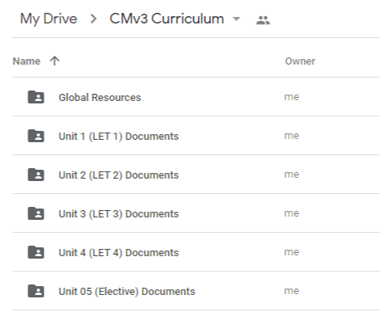

* + 1. Curriculum may be downloaded by Unit, Chapter, or Lesson by right clicking on the desired folder and

selecting DOWNLOAD. Download speeds will vary depending on file size and Internet speed. Take care to save these downloads in a file you have ready access too.

* + - 1. Best practice is to download each LET level separately because of file size.
      2. Google will zip each file to increase download speeds, please leave the webpage WHEN prompted

to do so.

c The materials will now available on your computer for use. If you believe any of the files from the

download are missing download them again separately.

* + 1. Use these resources to create an online learning environment in your school’s LMS.
    2. The AJROTC Distance Learning courses, formerly Cadet DL, contained in Google Classroom is an exemplar

of a constructed online learning environment in current use. Access may be requested by emailing [armyjrotcdlcourses@gmail.com](mailto:armyjrotcdlcourses@gmail.com).

* + 1. Please direct all questions concerning content and availability to [armyjrotcdlcourses2@gmail.com](mailto:armyjrotcdlcourses2@gmail.com).